FDP REPORT
FACULTY ENTREPRENEURSHIP DEVELOPMENT PROGRAM (FDP)
Jointly Organized by
NATIONAL FOUNDATION OF INDIAN ENGINEERS (NAFEN)
&
MANAGEMENT EDUCATION & RESEARCH INSTITUTE (MERI)
Sponsored by
NATIONAL SCIENCE & TECHNOLOGY ENTREPRENEURSHIP DEVELOPMENT BOARD (NSTEDB)
Govt. of India
23rd December, 2014 to 6th January, 2015
at
MERI, New Delhi

FDP Inaugural was held on Dec 23rd. Dr. Anita Gupta Director /Scientist-F NSTEDB , Department of Science and Technology, Ministry of Science and Technology, Government of India was chief guest who enlightened the audience about incubation centers and similar other initiatives promoted and supported by NSTEDB. Sh. I P Aggarwal Chairman MERI , Guest of Honour welcome the delegates and blessed the audience with his kind words. Prof. Lalit Aggarwal ,Vice President of MERI talked about significance of this topic for FDP . Dr. V K Kapoor, Director, MERI and .Sh. S K Aggarwal, CFO, MERI were the guiding force behind conducting this programme. Dr. P K Gupta, Secretary General, NAFEN has talked about fifteen days programme schedule . Prof. Y L Grover, DG, MERI delivered vote of thanks to the delegates.Prof. A.K Agrawal Dean Academics and Prof. Aseem Makhija Dean Corporate also graced the occasion.

Participants had a great learning in fifteen days. Evolution of Management and Introduction to Entrepreneurship was discussed by Dr.P.K Gupta.He is a gold medalist both in B.E. (Electrical Engg.) from TIET, Patiala and Masters' of Business Administration (MBA) from F.M.S., Delhi. He has a diploma in International Trade from ACTIM, France and Contract Administration from
C.E., USA. Has a Doctorate in Management (PhD) from KPI (Ukraine) and Doctor of Sciences (D.Sc) from MUEM, Russia.

Communication Skills, Stress Management, Management by Objectives (MBO),Time Management topics were dealt by Ms.Manisha Gill who is a practicing Counseling Psychologist. Masters in Counseling Psychology from Amity University.

Participants came to know in detail about Management of Change ,Team Working, ISO -9001 & TQM by resource person Prof. P.N. Kathuria who is a Quality Management System Auditor - 2000 & Former AGM (Training), SAIL.He is a Chartered EngineerB.Sc. Engg. (Mech), FIE.

Motivation,group Dynamics, Introduction to SWOT Analysis, Negotiation Skills, Leadership Qualities and Personality Development topics were discussed by Mr. Praveen Rajpal, Former Country Manager, Tadiran Telecom (TTL). He is an Engineer with Post Graduate Diploma in Business Management.

Capital Markets & EM , Balance Sheet & I&L Account, Working Capital Management topics were explained by Prof. Shipra Agarwal, a Senior Faculty, FM .Dr Shipra is an academician with B.Com from Delhi University, M.Com (Double) from H P University & EILLM University and MBA from AIMA with financial management as specialization.

How to Identify Products by Entrepreneurs ,Traits & Skills of a Successful Entrepreneurs was an interesting talk for all participants delivered by Dr. David WittenbergCEO, The Innovation Workgroup New Delhi. Dr. David Wittenberg a versatile, creative business leader with over 30 years of consulting, entrepreneurial, marketing and management experience. He is an author of The Executive's Guide to Innovation (Cresthaven 2008).He has very deep command over Innovation systems, techniques and tools.

All the sessions were informative and interactive. Indeed, fifteen days well spent for learning and growing.
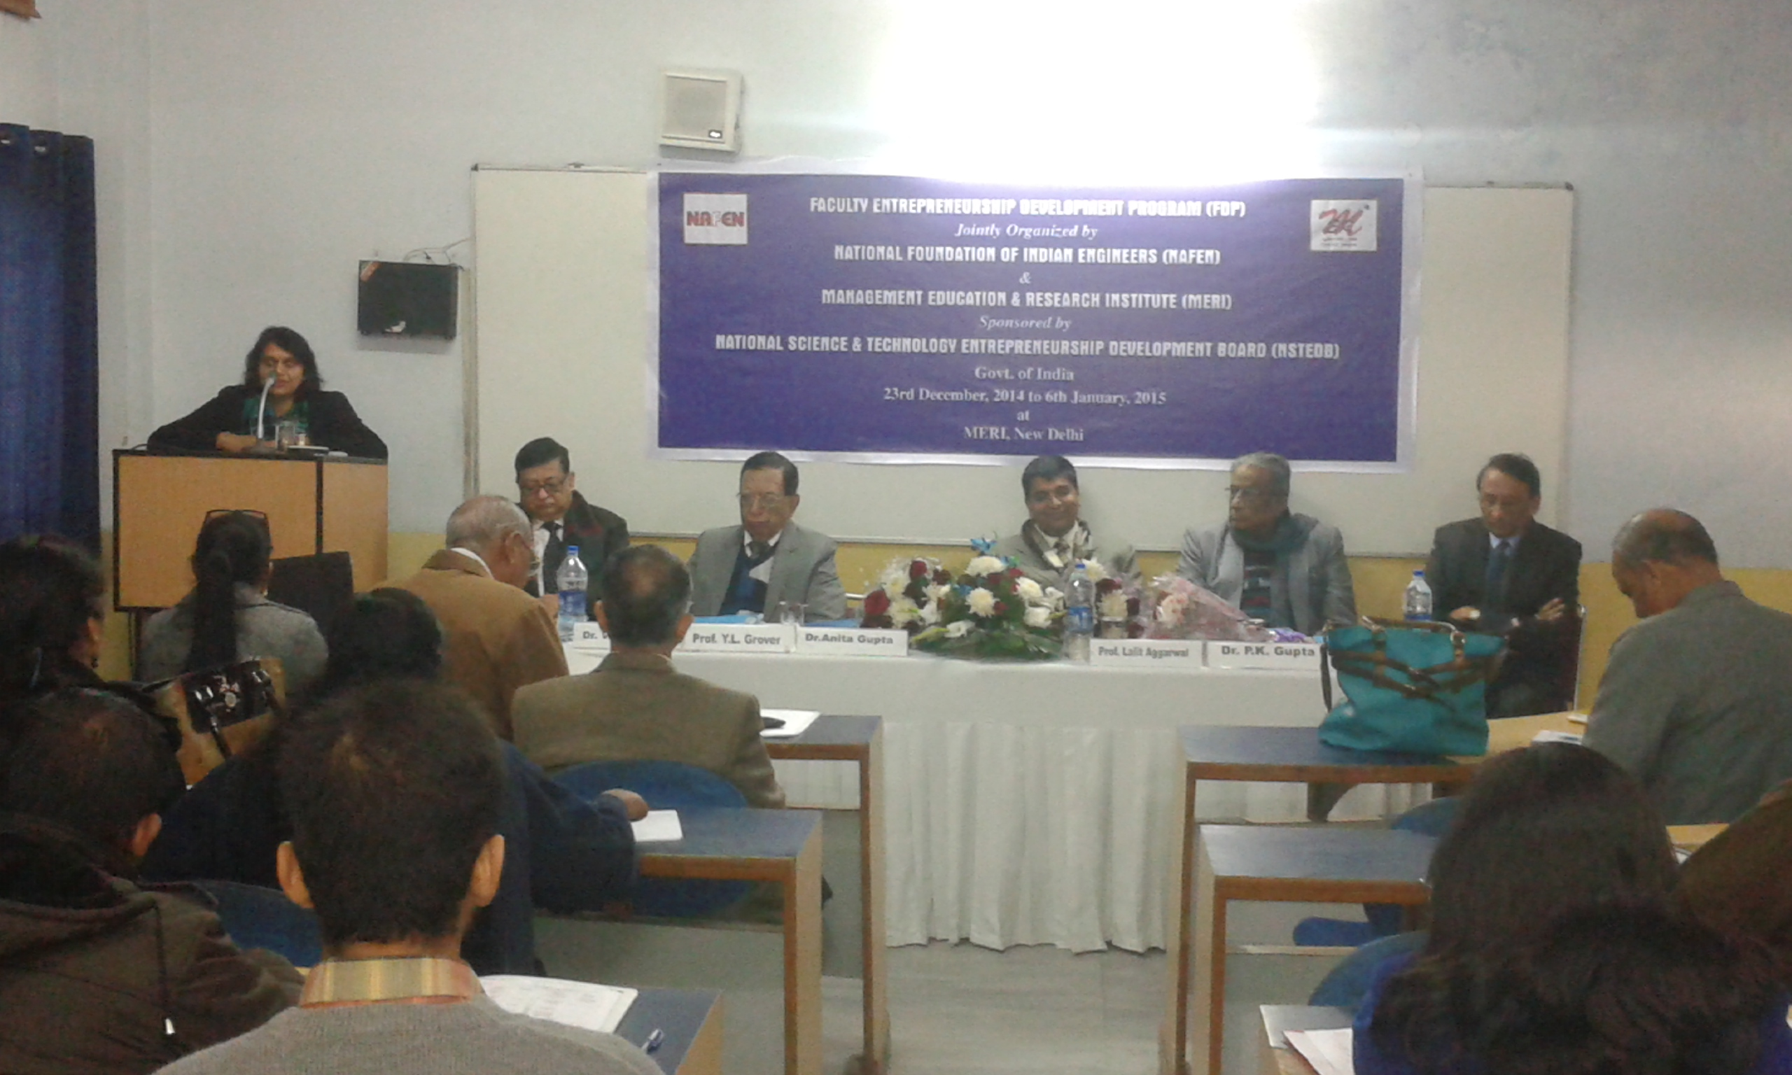

CC:

- Dean- For information please
- DG –For information please
- VP- For information please

