APRENDEMOS 2018
17th National IT Seminar- ‘Aprendemos’ on “Data Science and Machine Learning: New Frontiers & Challenges” on 6th October, 2018 (Saturday)
Venue: College auditorium

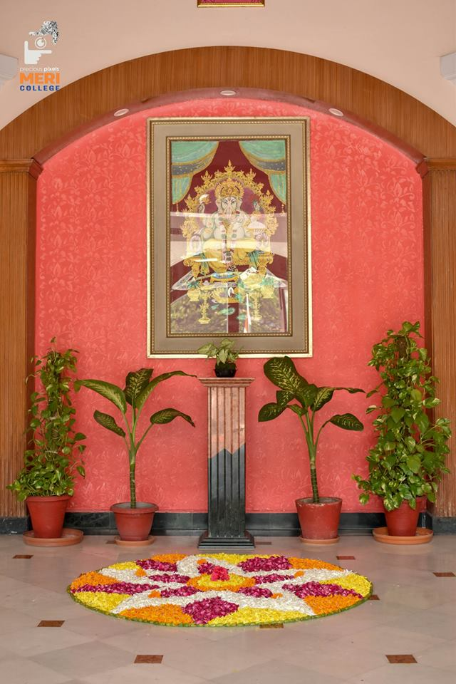 | 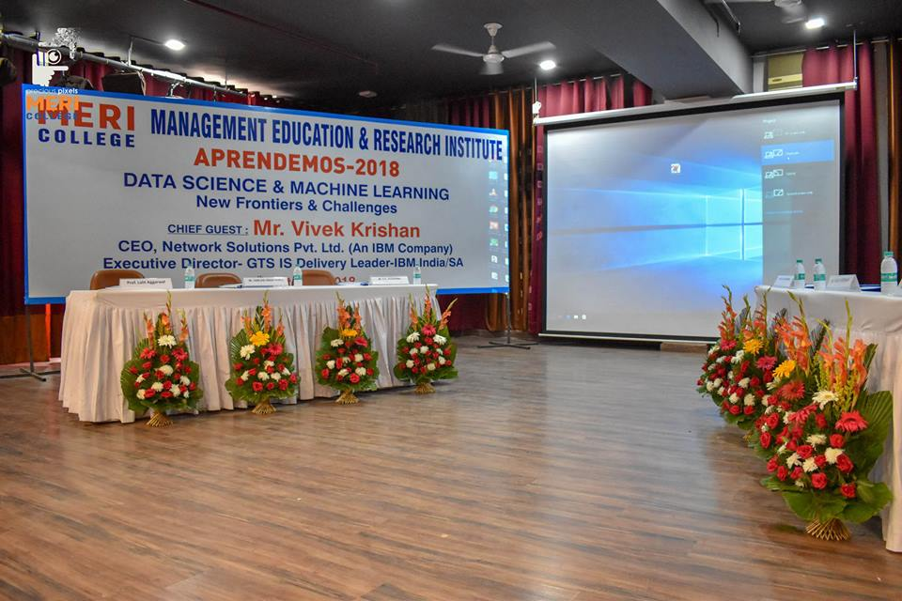
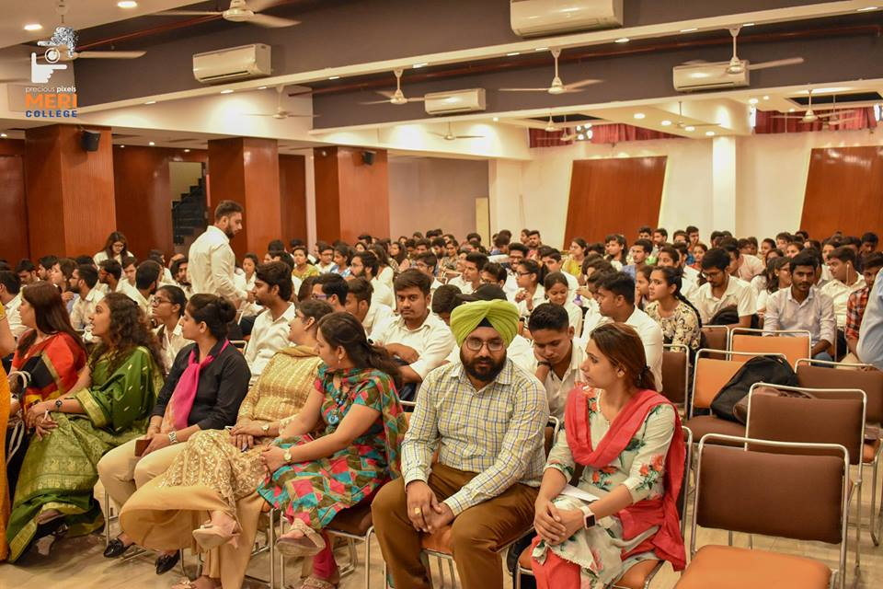
For this event the honorable chief guest was Mr. Vivek Krishan, CEO, Network Solutions Pvt. Ltd., Executive Director – GTS IS Delivery leader – IBM India/South Asia and the guest of honor was Mr. Harjas Singh Popli, Head HR, Network Solutions Pvt. Ltd.
Apart from this, speakers were Mr. Varun Bagga, Growth Manager Digital Analytics and Customer lifecycle strategy, Paytm Mall. Another speaker was Mr. Rishabh Jain, Service Delivery leader, American Express.
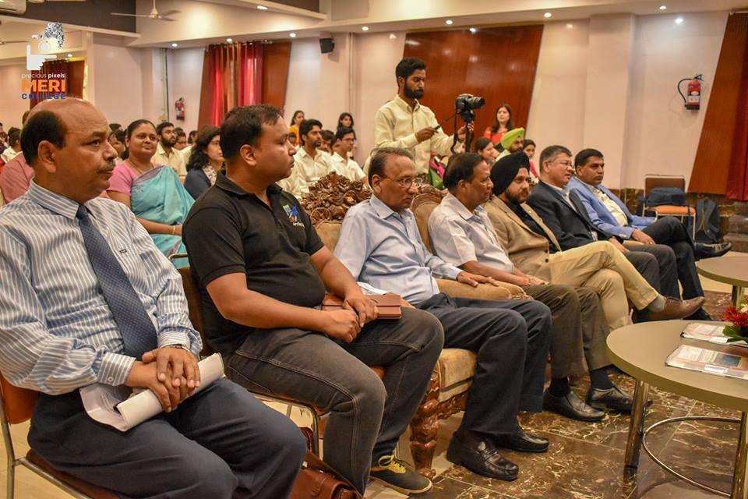
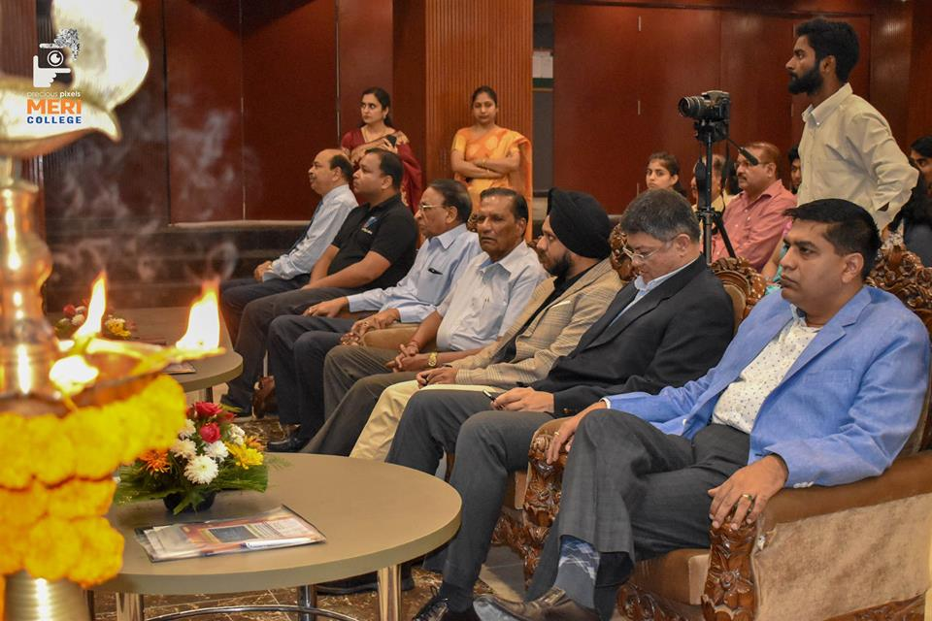
There was also project competition in which judge was Mr. Dushyant Gadewal, Founder, ArcTop Labs. The winners are provided internship, cash prize & certificates.
In the meantime, there was also exciting quiz session. The students of MCA, Btech, BBA & MBA were also involved.
INAUGRAL SESSION
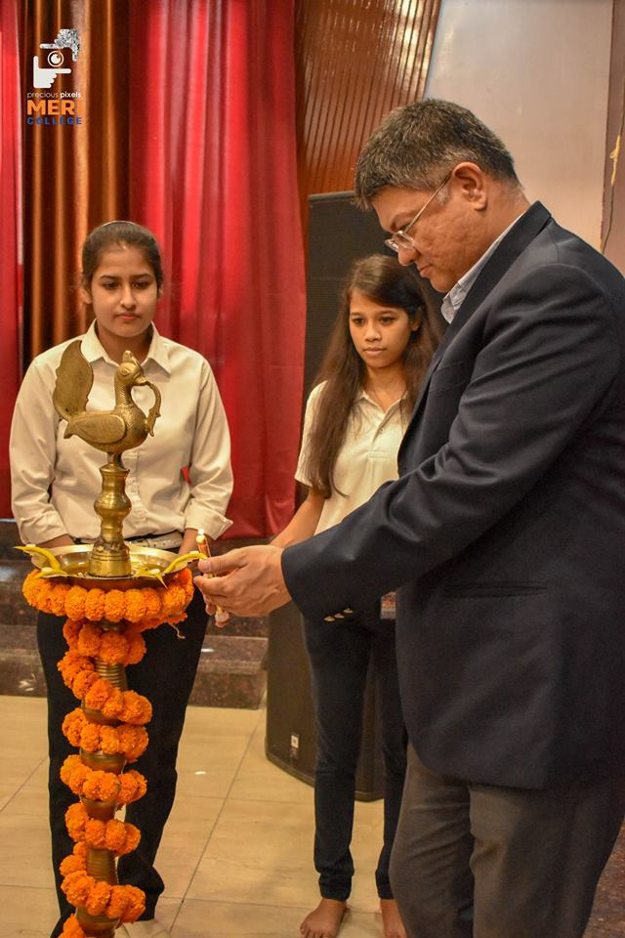 | 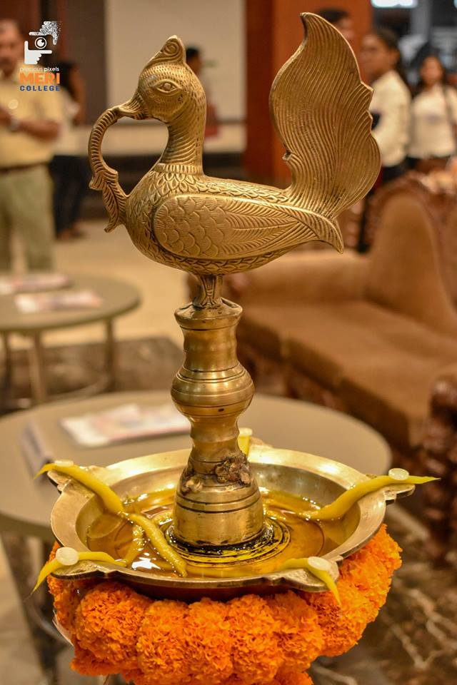 | 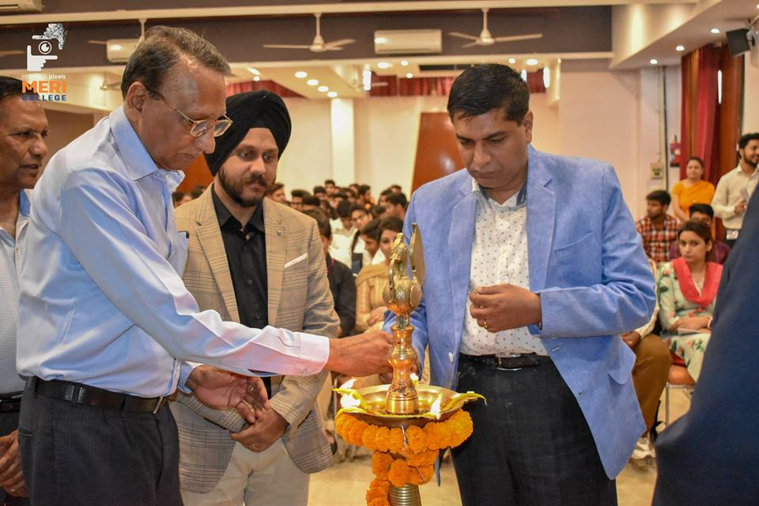

We welcome our chief guest Mr. Vivek Krishan for lighting the lamp. Also welcome our faculty members and students or different institutes also.

Welcome speech was given by SH. IP Aggarwal, President and the guiding force behind this whole endeavor of MERI. Professor Lalit Aggarwal, vice president, MERI group of institutions gave his welcome address to the chief guest. After then Mr. Vivek Krishan told their experience and guides the students for further growth in data science & machine learning.
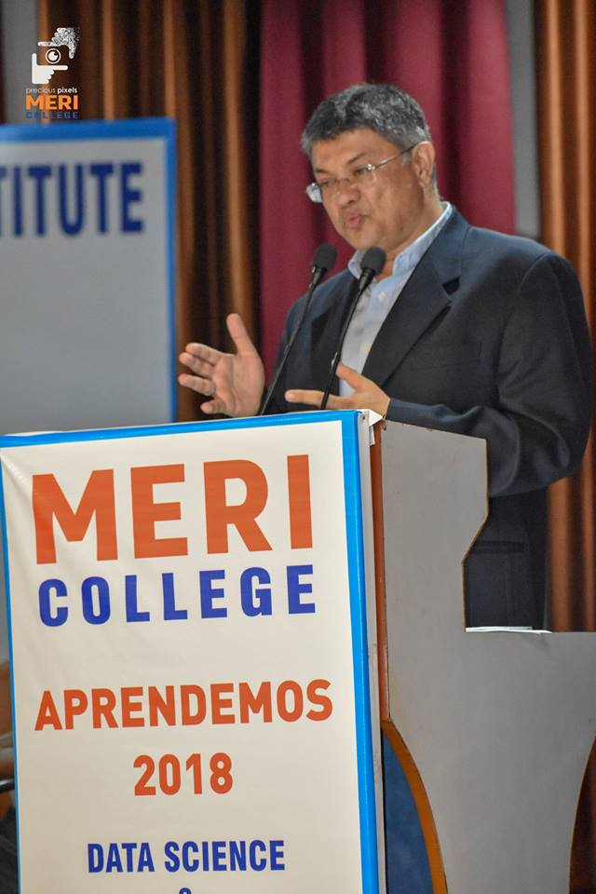 | 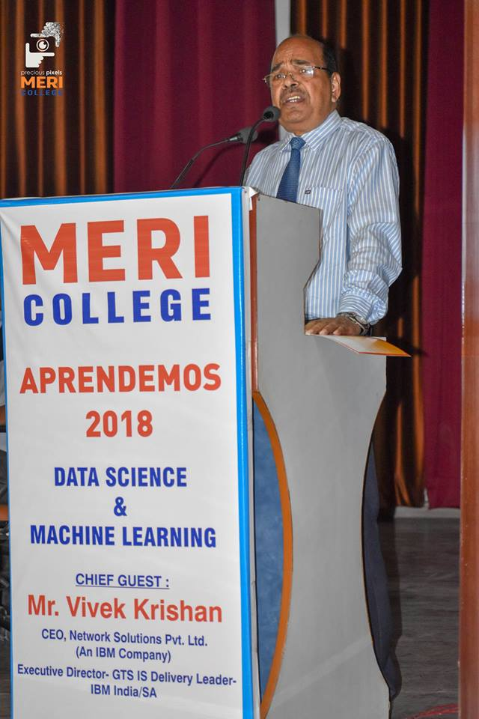
At the end of inaugural session, Prof. A K Aggarwal gave a vote of thanks.
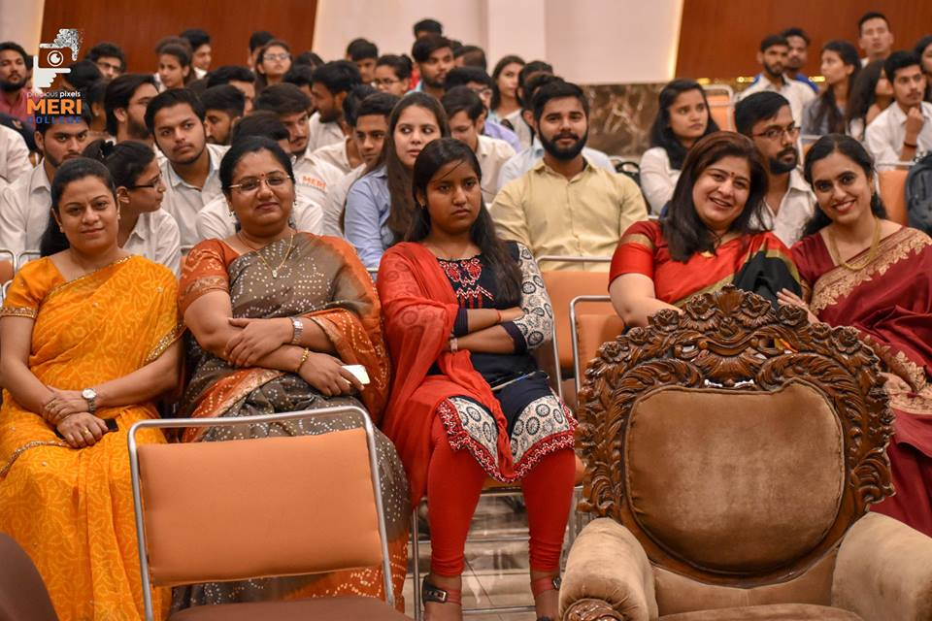
During this session, the students of MCA gave their presentations based on machine learning & IOT.
Sr. no. | Name | Project presentation
1 | Sakshi | Sentimental analysis
2 | Lucky, Rakshita & Sushant | Home operable portable embedded system
3 | Samarth & Shivam | Jarvis

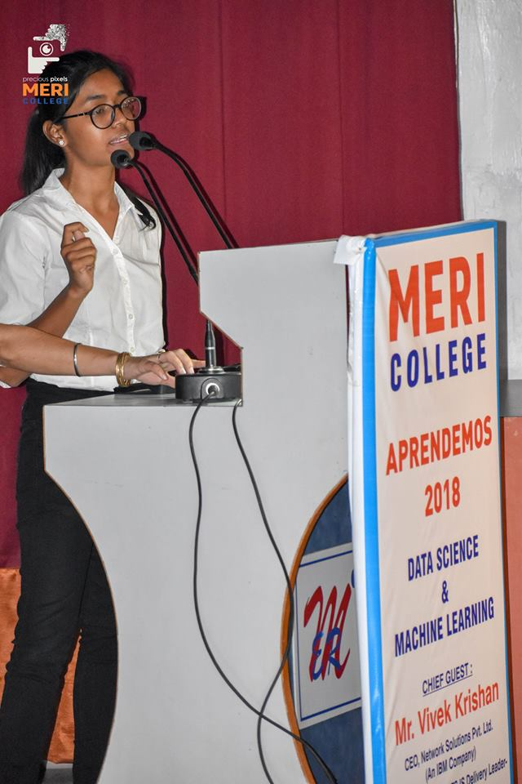 | 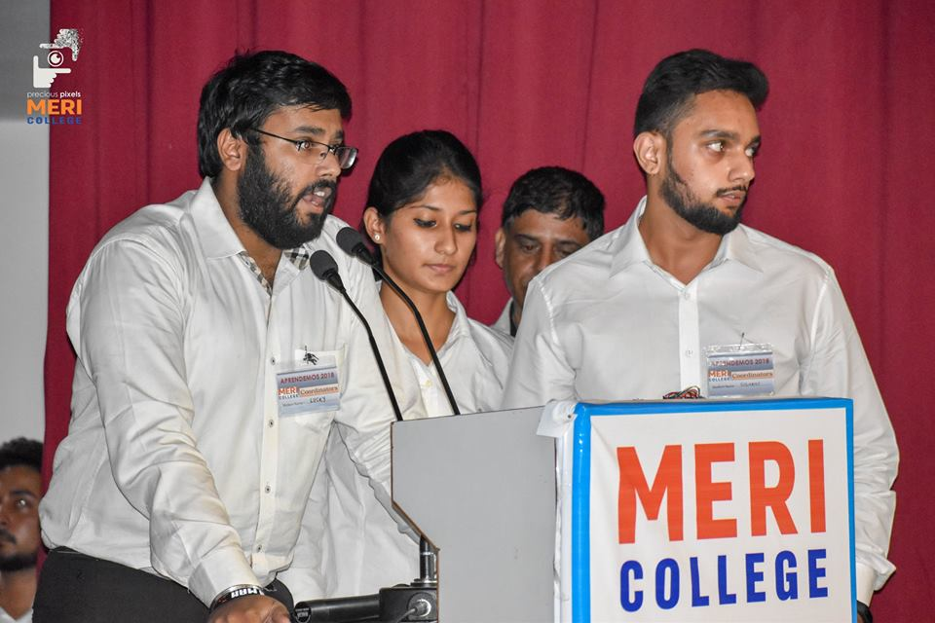 | 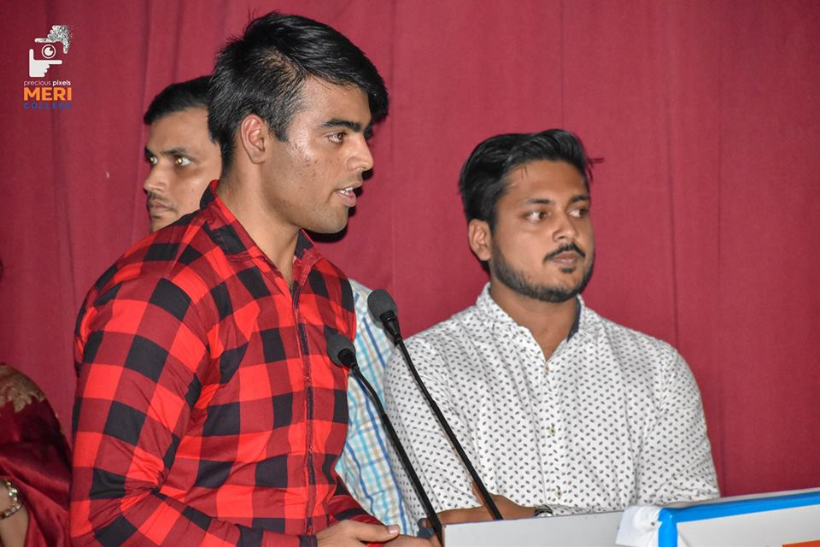
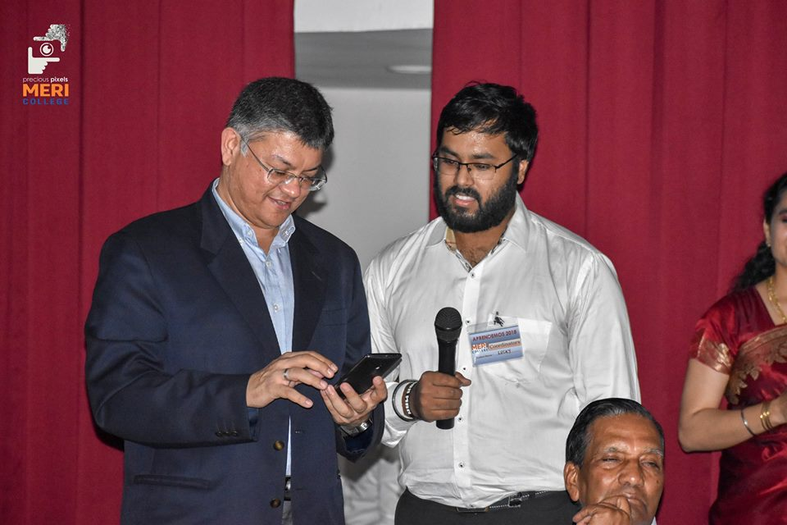 | 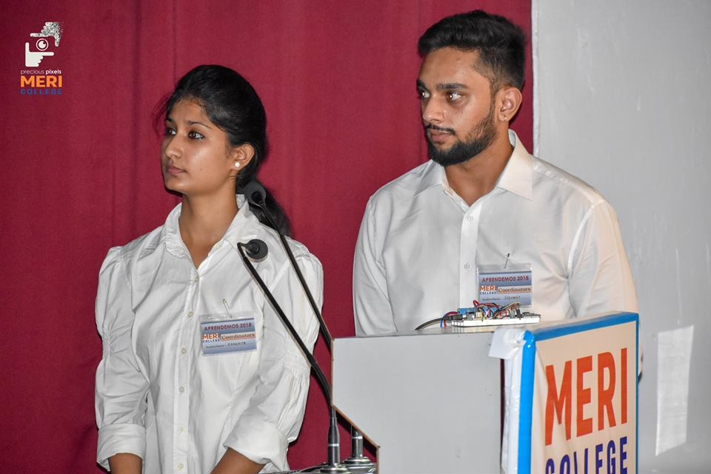 | 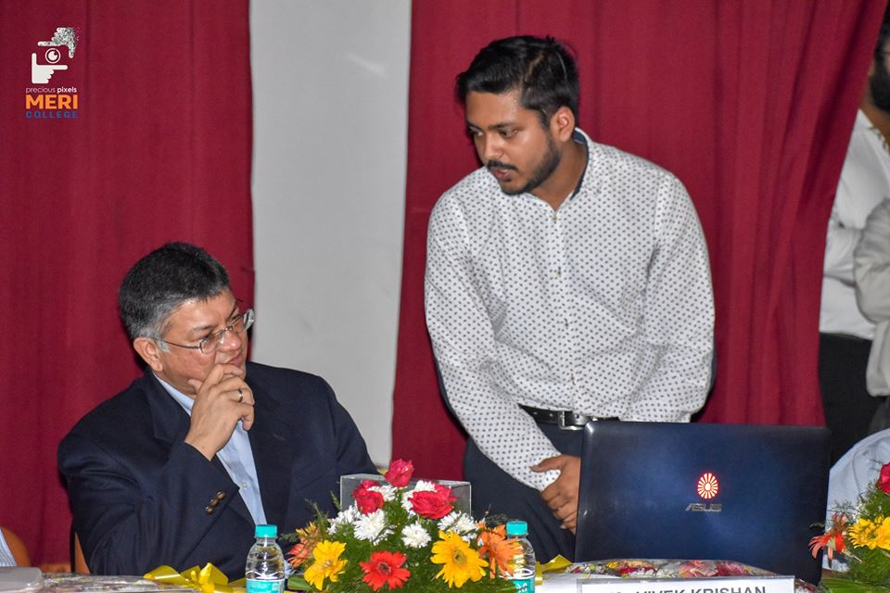

TEA BREAK (1:00)
Quiz session attended by various students of MCA, BTECH, MBA & BBA which was of 15 minutes and conducted by Amit Pal and Jyoti Pal.
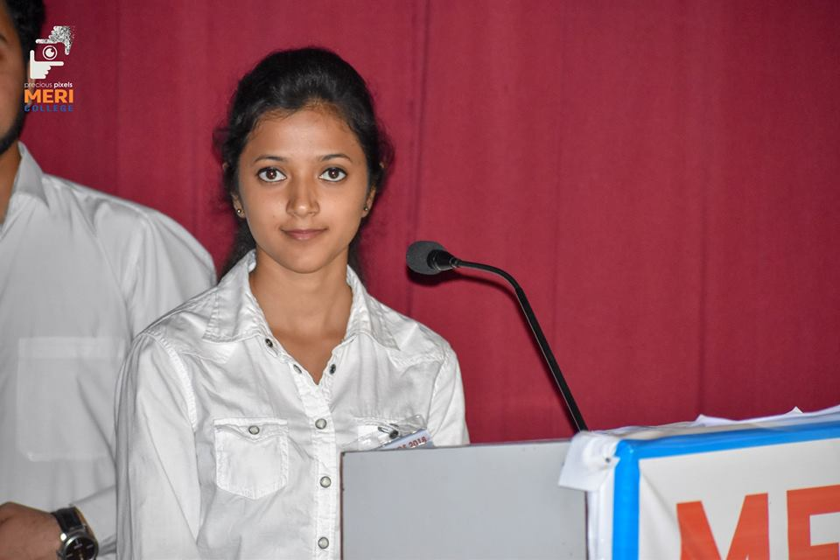 | 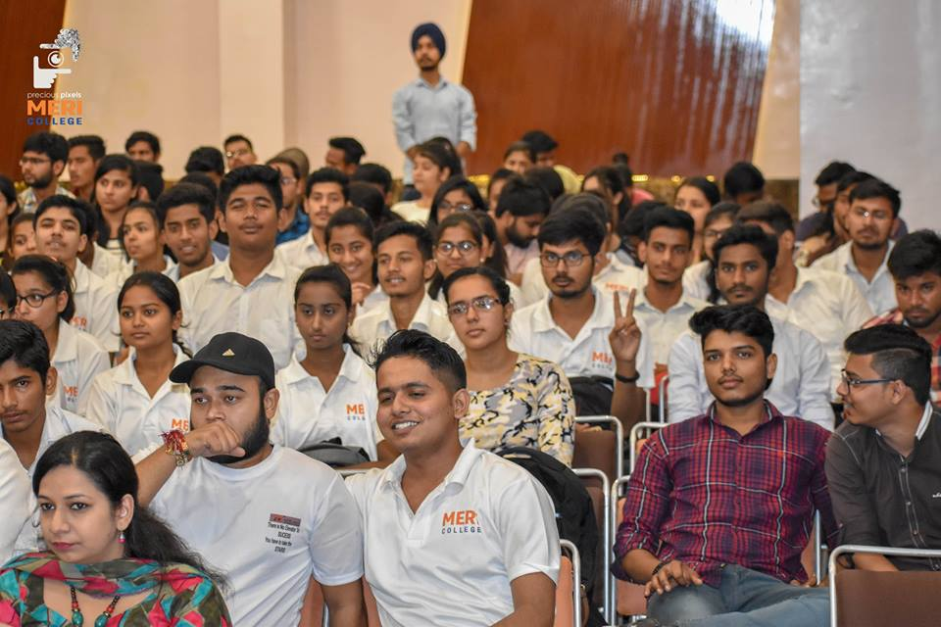
SESSION 1: (1:30)
First Technical Session conducted by Mr. Varun Bagga. He gave an interesting session on Artificial Intelligence, Big data & Machine Learning.
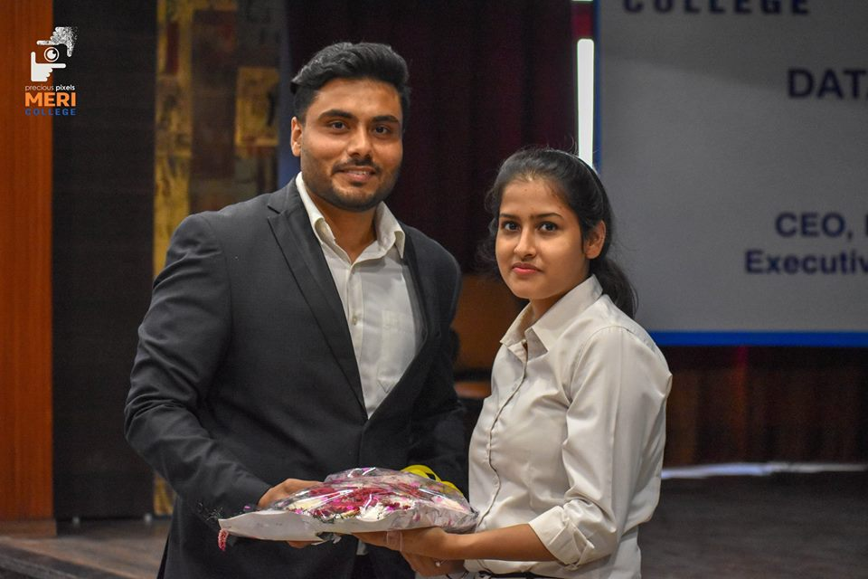 | 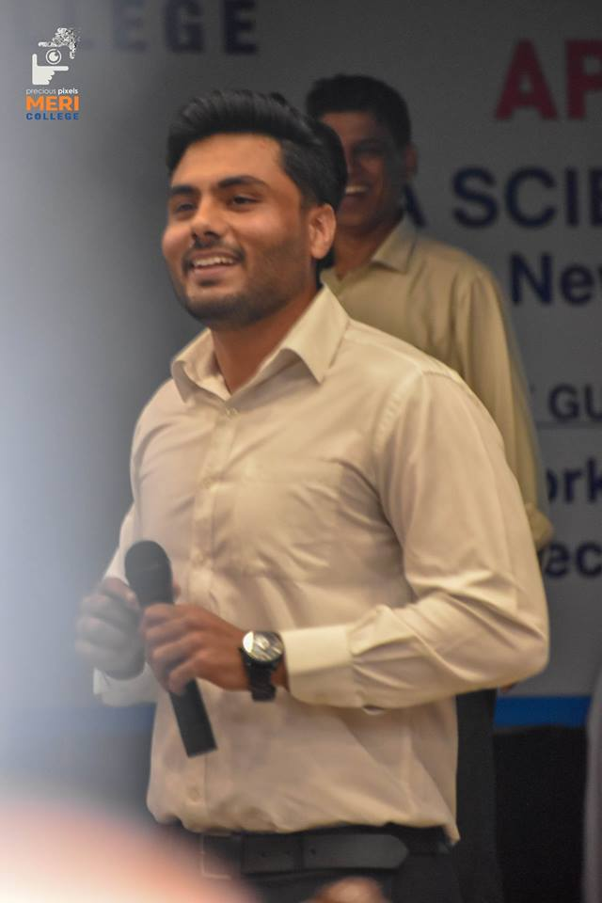 | 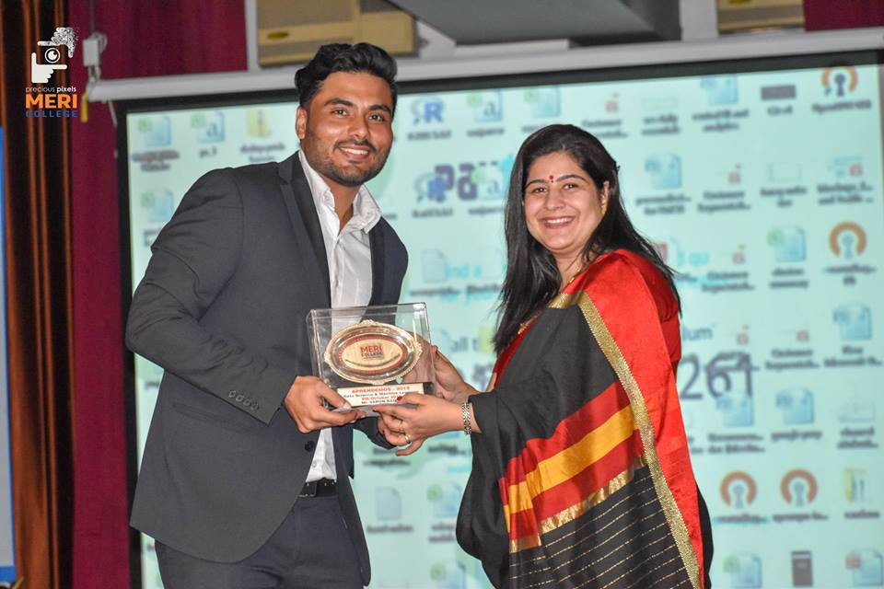

Session 2: (2:30)
Second Technical Session conducted by Mr. Rishabh Jain. He told deeply about how big data and data science value is trending in the future scope.
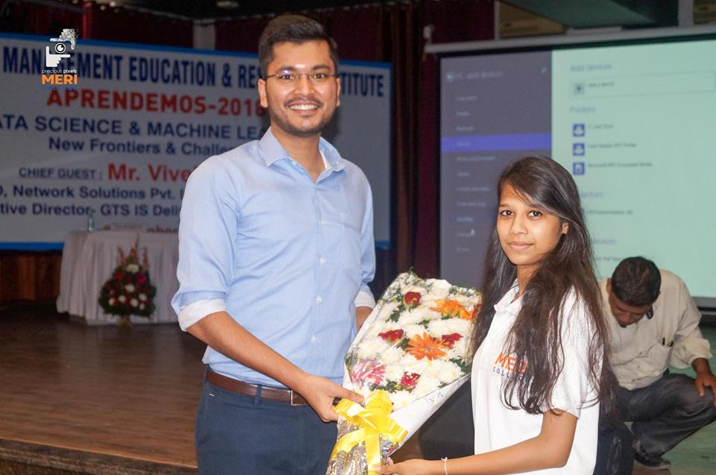 | 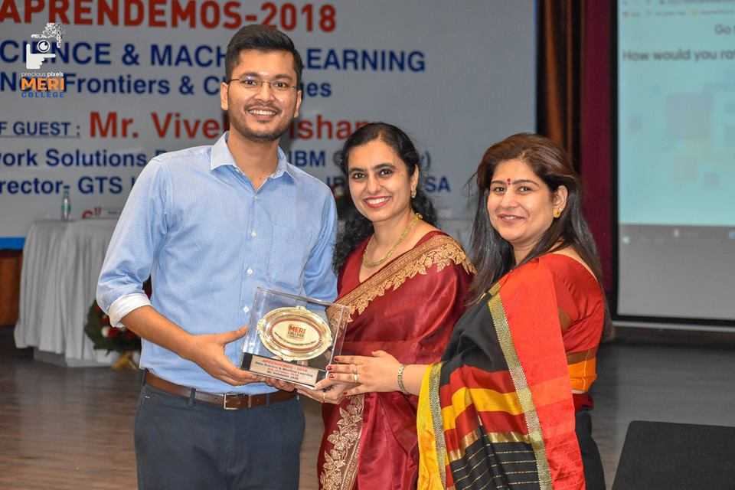
AFTER LUNCH BREAK
In the inter-college project/paper competition after deliberation by our esteemed judge Mr. Dushyant Gadewal, Founder, ArcTop Labs, has 11 years of experience of building SaaS Technology solutions.
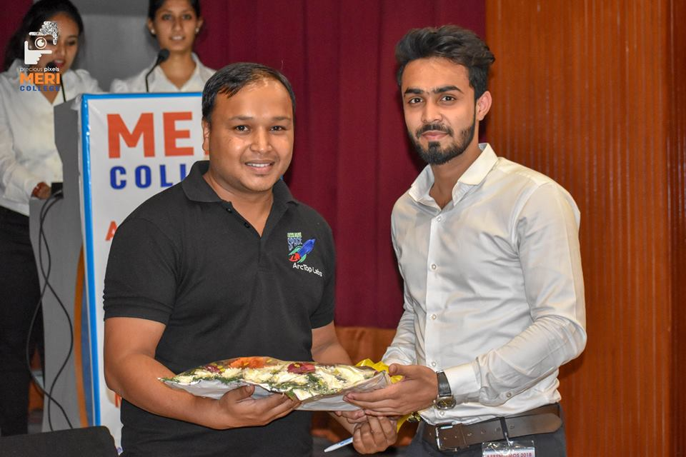 | 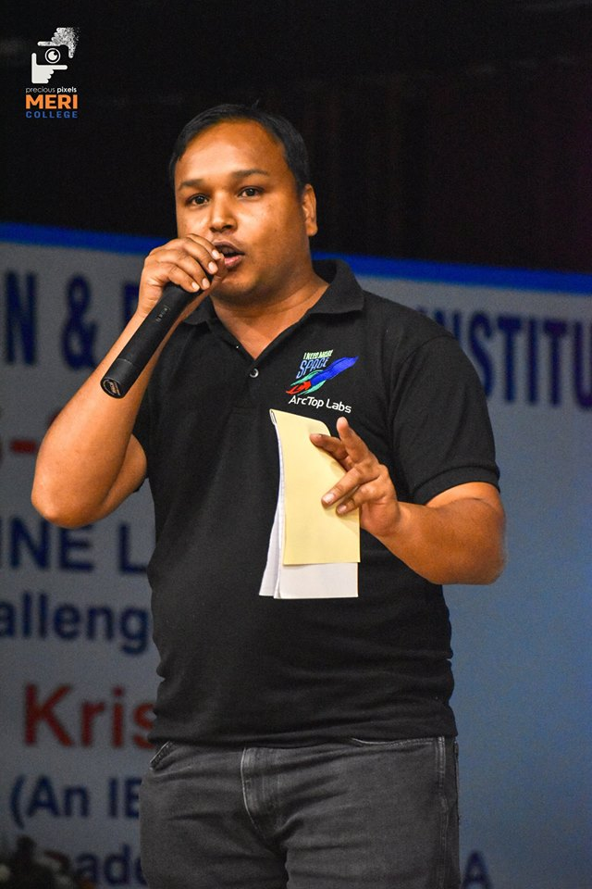 | 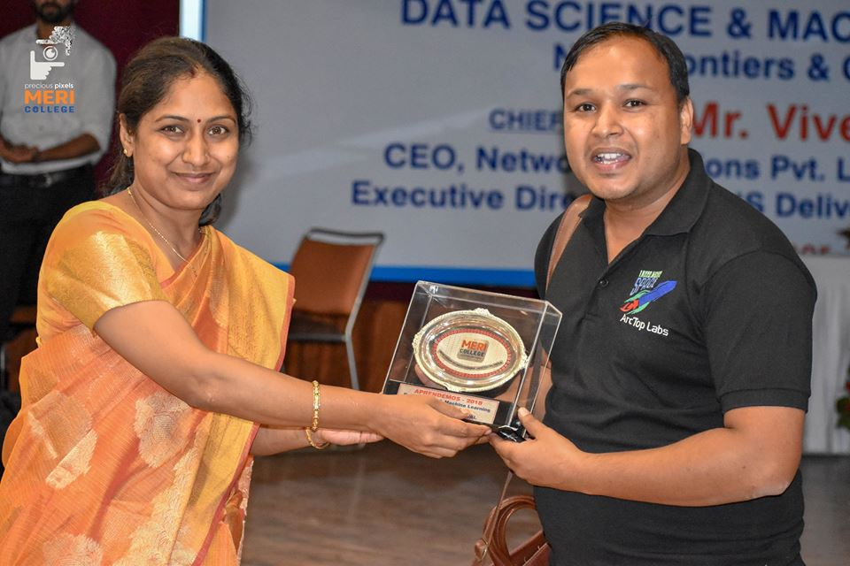

PROJECT PRESENTATION
Sr. no. | NAME | PROJECT/ RESEARCH PAPER
1 | Sakshi & Jyoti | Sentimental analysis
2 | Lucky, Rakshita & Sushant | Home operable portable embedded system
3 | Samarth & Shivam | Jarvis
4 | Anurit & Rajveer | Security App
5 | Ayush Jindal | E-news
6 | Prateek, Apoorva & Cheena | Home automation
7 | Dhruv | Research Paper
8 | Rakshika, Ajeet, Abhishek | Child welfare
9 | Sachin,Dhruv | Automated car
10 | Rajesh | Opinion mining

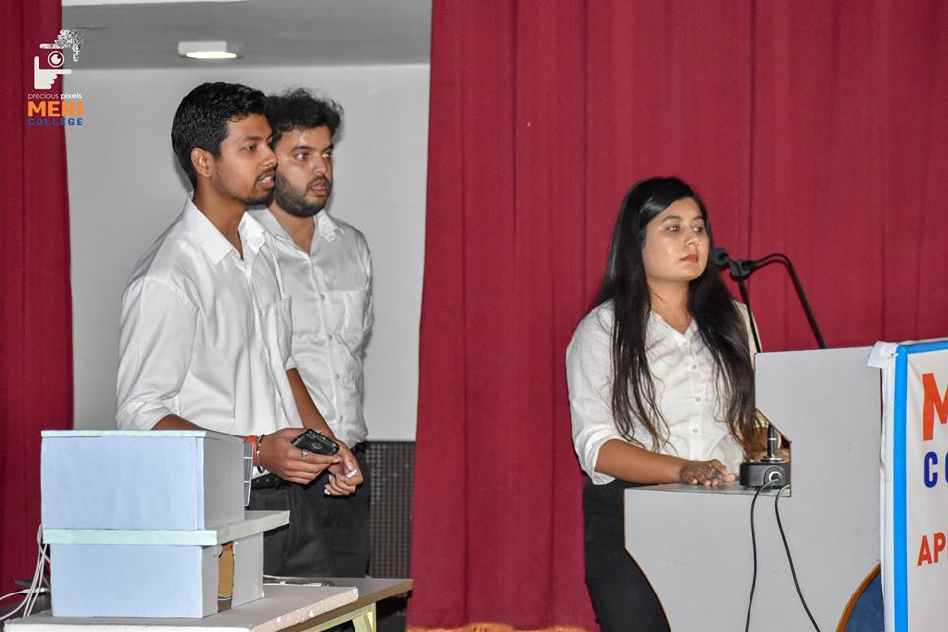 | 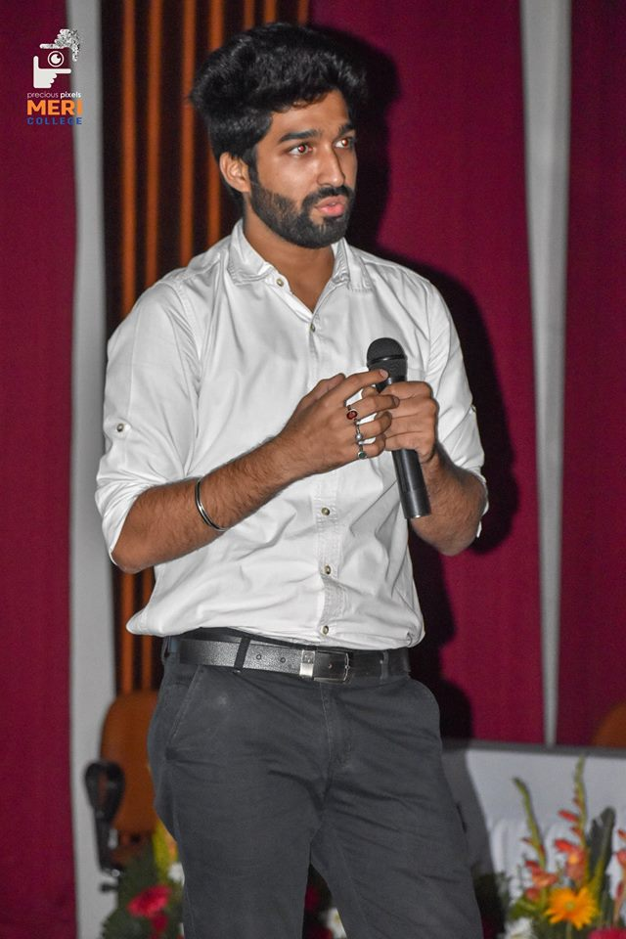 | 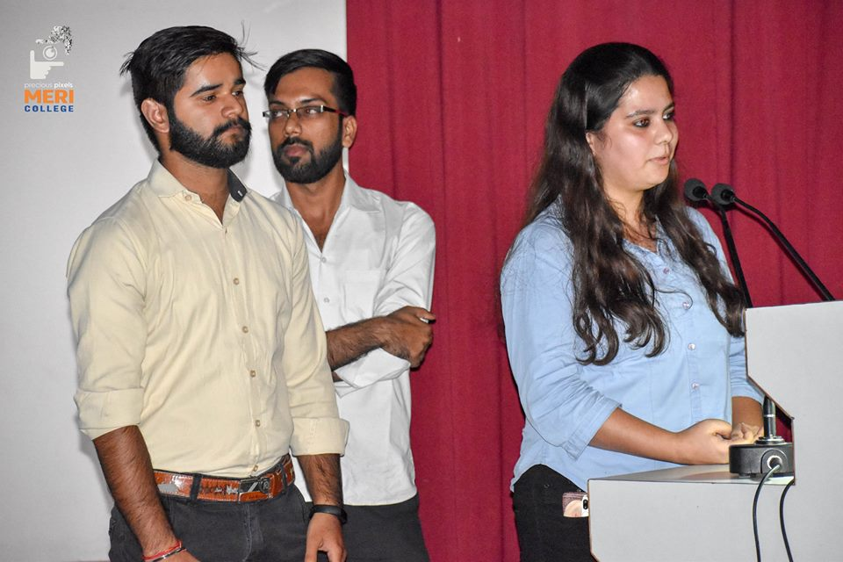
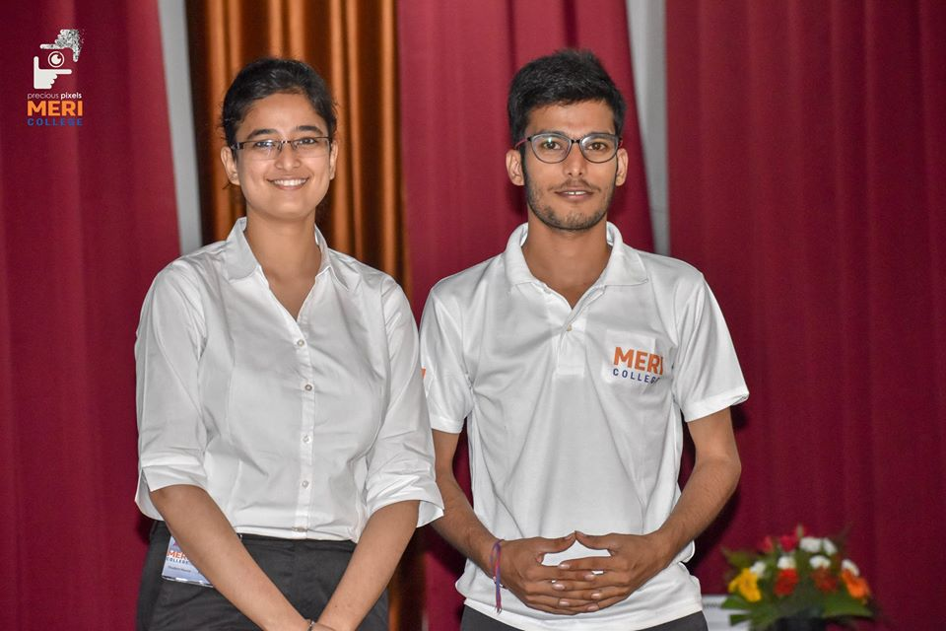 | 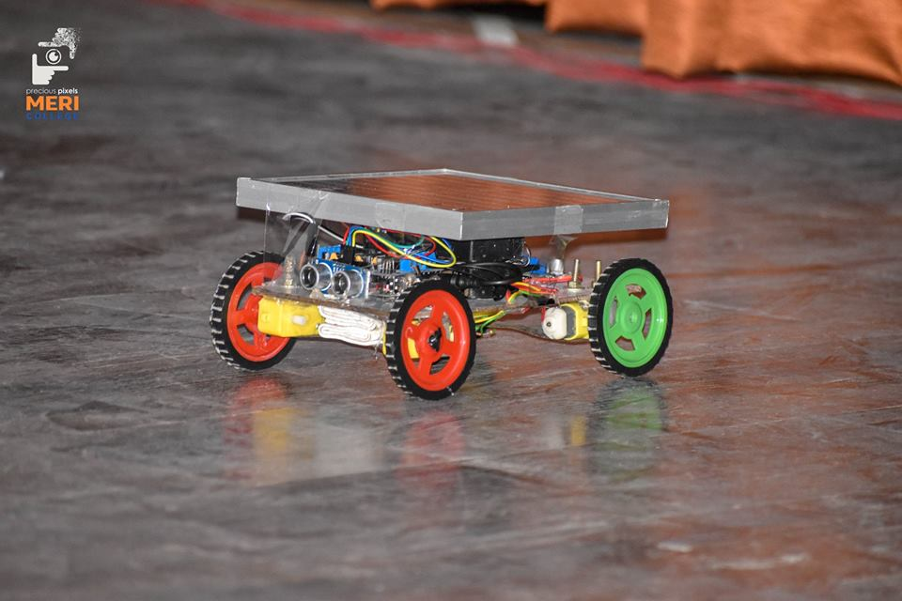 | 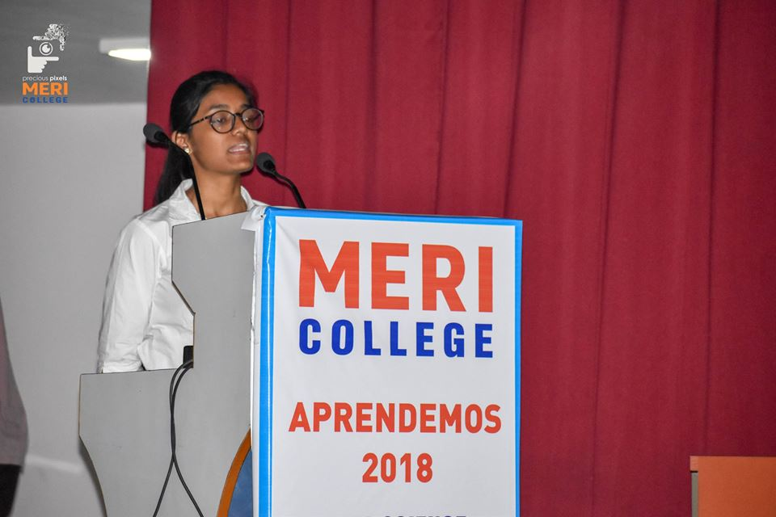
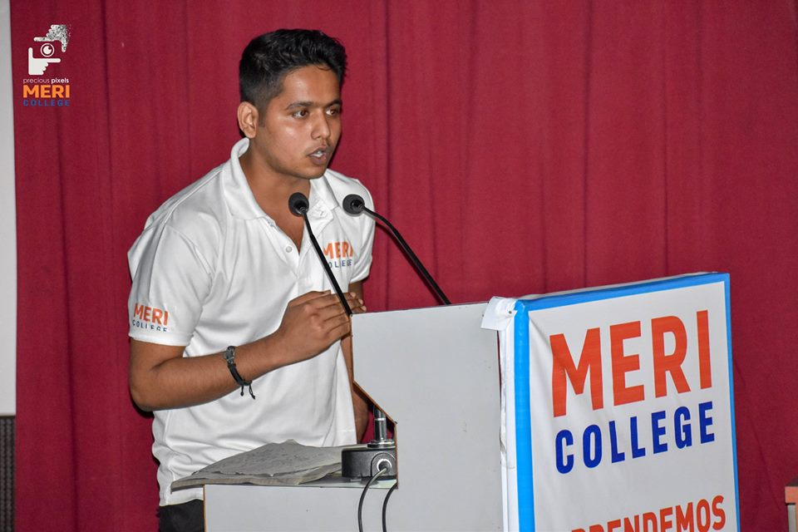 | 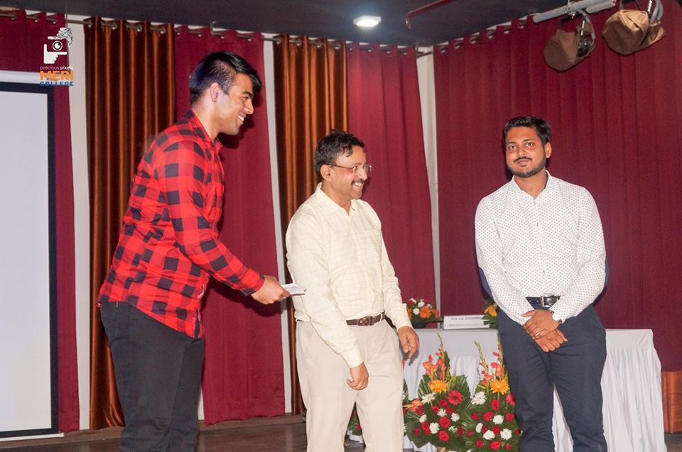 | 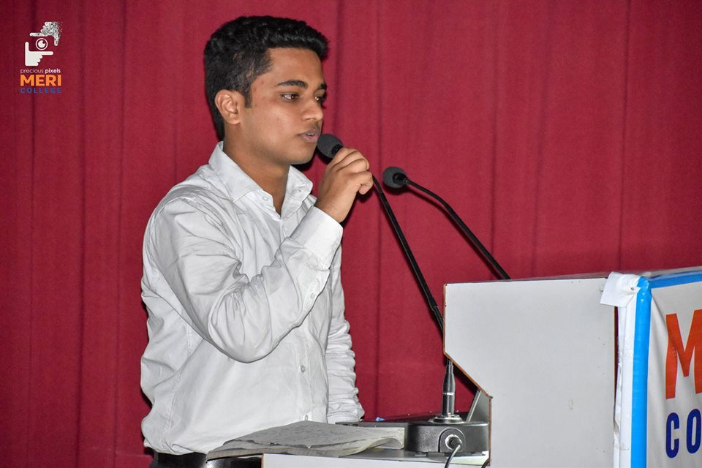

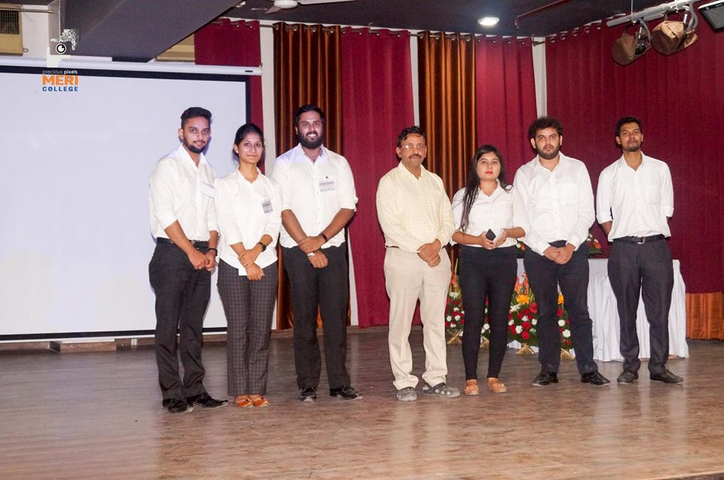 | 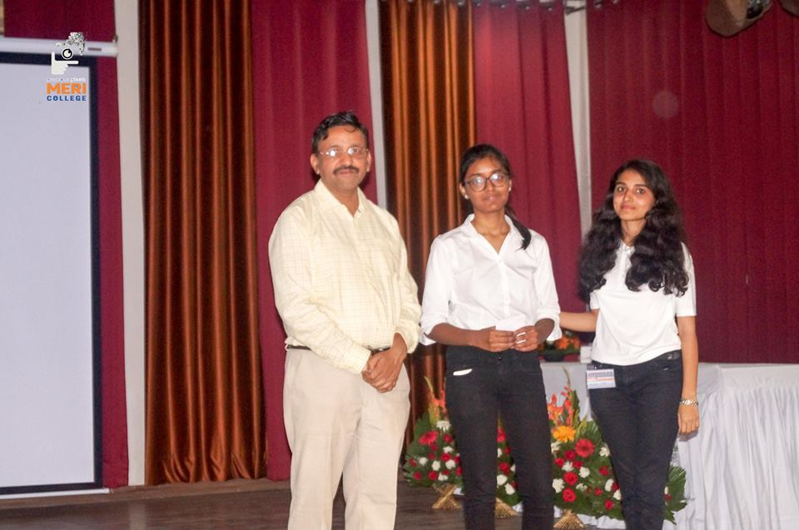

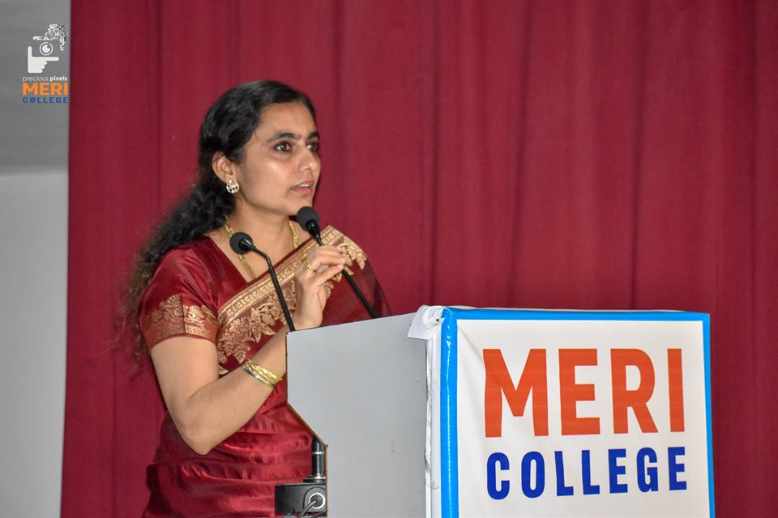 | 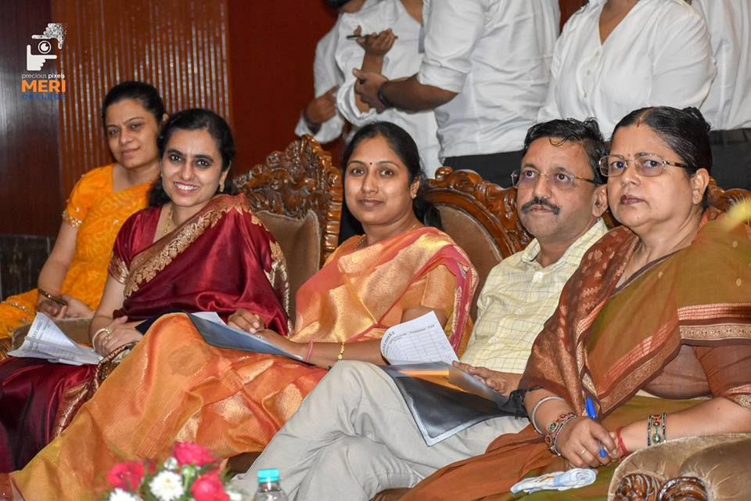

1st position was secured by Sakshi, 2nd position by Samarth and Shivam, 3rd by Lucky, Rakshita and Sushant and 4th position by Anurit and Rajveer.

END OF THE APRENDEMOS
