REPORT MARKETING SEMINAR

DATE: 13-10-18
VENUE: MERI AUDITORIUM
TIMINGS: 9:30 AM-4:30 PM
TOPIC OF THE SEMINAR: Harnessing Potential Marketing Trends 2018-19
ORGANIZER: MERI, MANAGEMENT DEPARTMENT

CHIEF PATRONS: Shri I.P.Aggarwal, Founder President, MERI
Prof. Lalit Aggarwal, Vice President, MERI
ORGANIZING COMMITTEE: Shri. A.K. Agrawal, Dean, MERI
Ms. Gurpreet Kaur Chhabra, Assistant Prof., MERI
Mr. Parmjot Singh, Assistant Prof., MERI

CHIEF GUEST: Mr. Ushpreet Singh Bawa,Director, Account Management,Small Domestic Appliances & Lighting

SPEAKERS INVITED: Ritesh Malik, Director Sales,Palm Green Hotels/Resorts
Ms. Reena Yadav, GM, Sales & Marketing,Sai Com Codes Flexoprints Pvt.Ltd.
Mr.Akant Garg, State-Coordinator-Retail, Delhi NSQF
Mr.Amit Chand, Customer Life Cycle Marketer.

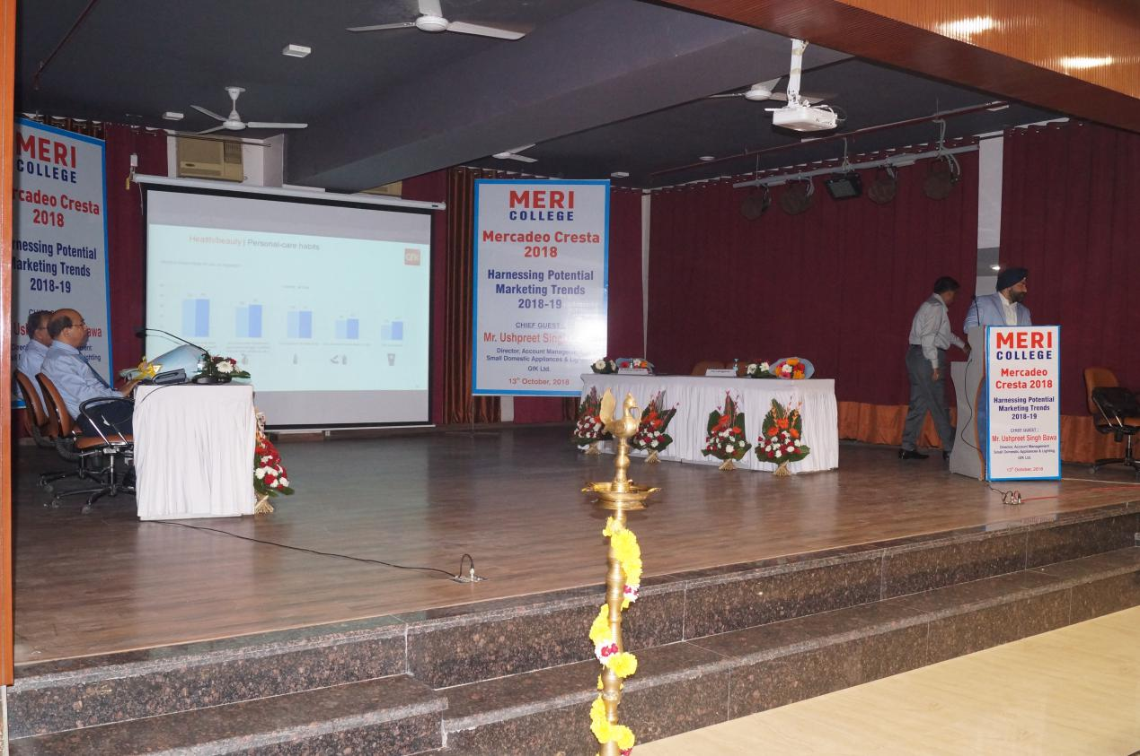

OBJECTIVES OF THE SEMINAR:
1) To explore, identify and analyze the prospective trends in various Industrial Sectors in India.
- To understand the ways and methods adopted by the companies for trend spotting from business perspective.
- To evaluate the benefits that marketers draw from early trend identification and analysis process.

The seminar began with the Lamp Lighting ceremony and Saraswati Vanadana,

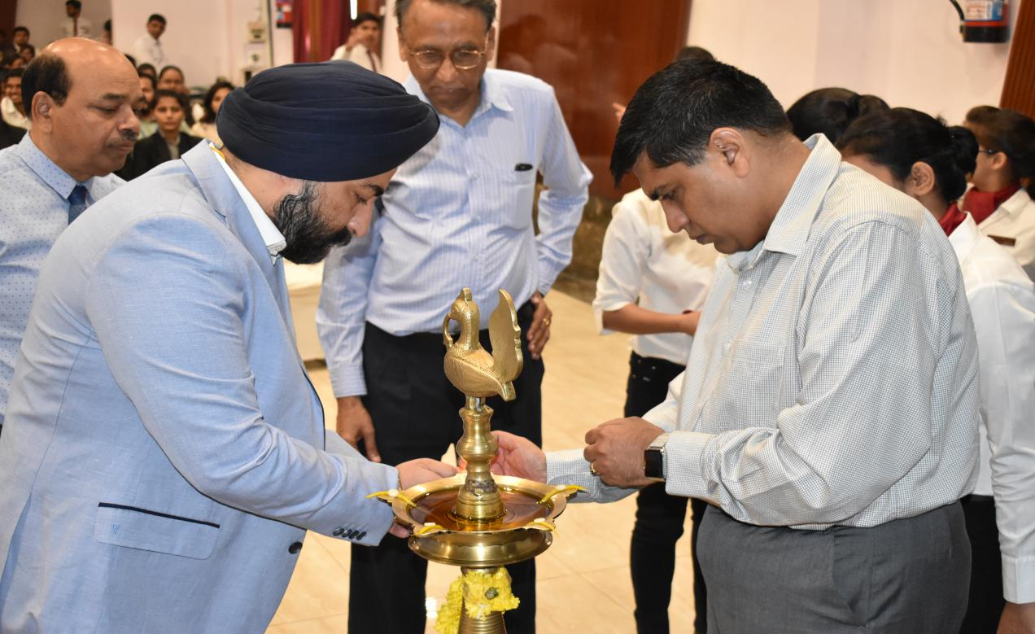

followed by a presentation titled “ A Dive in to Marketing Trends, Success Stories from the Corporate World”, delivered by Aman Upadhyay and Sakshi Mishra of MBA semester 1.

The inaugural session began with a Welcome address by the Vice President and audience address by the chief guest followed by vote of thanks by the Dean.
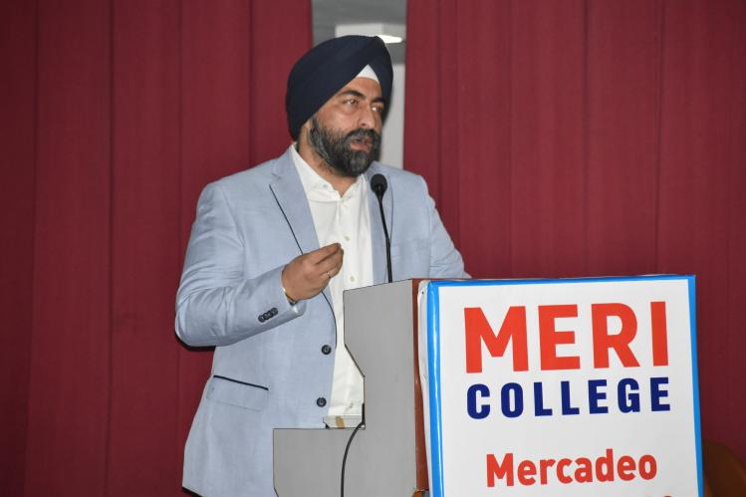

Technical Session-I had two presentations, ‘ Summer Internship Experience in France’ by semester-3 students,Uttkarsh and Shelly.
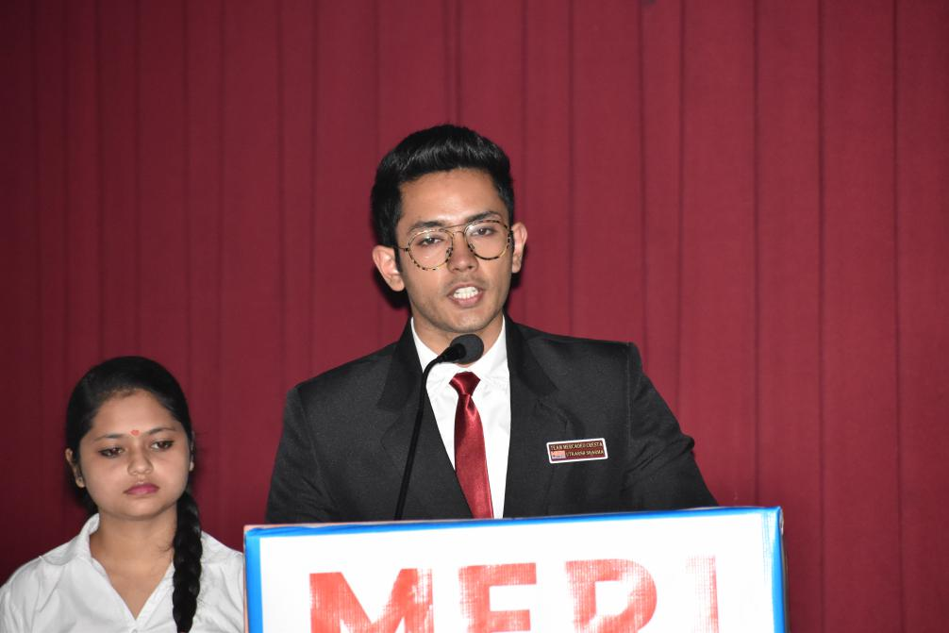

IInd presentation was by Mr. Ritesh Malik, on ‘The Current Marketing Trends in Hospitality Sector’.

Technical Session II had three presentations, By Mr. Amit Chand, ‘ Future Trends and Importance of Customer Life Cycle analysis in Automobile sector’.

Ms. Reena Yadav, delivered a presentation on ‘The Growth and Potential of Packaging Industry and the Current Marketing Trends in the Field of Packaging’.

Mr. Akant Garg, delivered a presentation on ‘Growing Role and Importance of Marketing in Retail Sector and Current Retail Marketing Trends’.

The Seminar was attended by 200 students from Semester 1 & 3 of MERI and 40 students from other colleges including NDIM, GIBS and Asian Business School. Two Faculties from NDIM and ABS had also participated in the Seminar.

