NATIONAL FINANCE SEMINAR 2020
ON
“LEVERAGING FINTECH FOR BUSINESS”
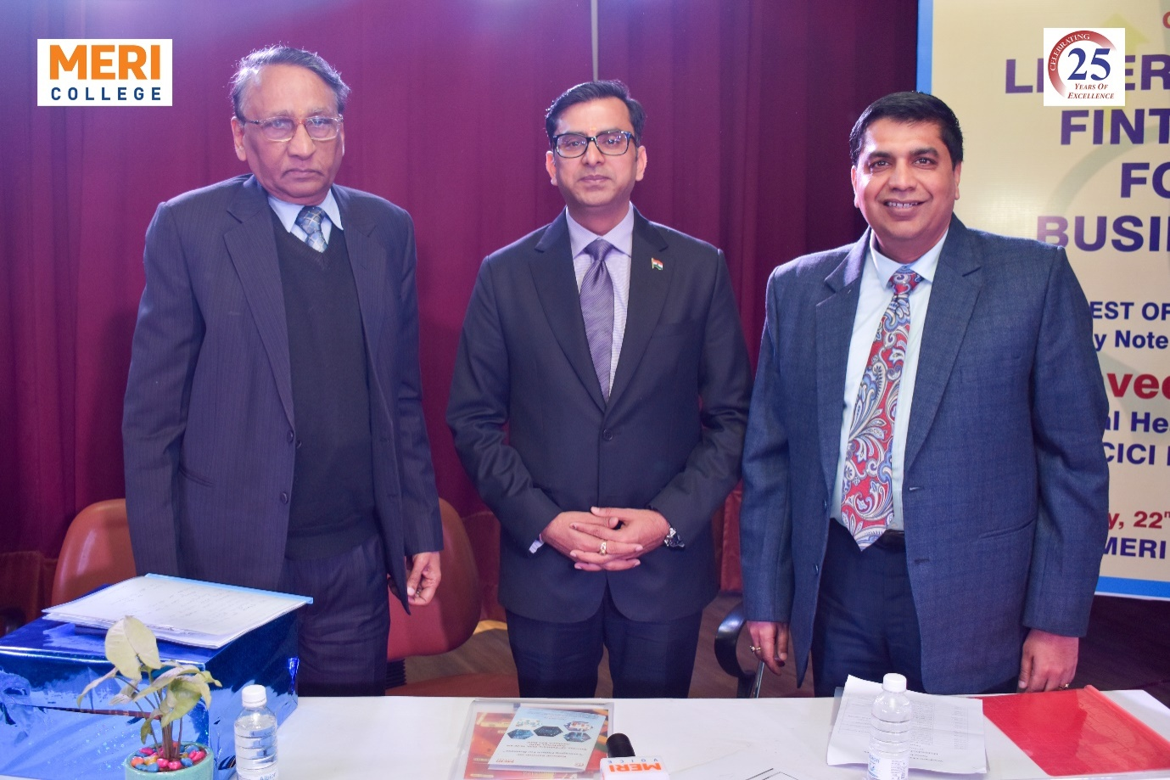
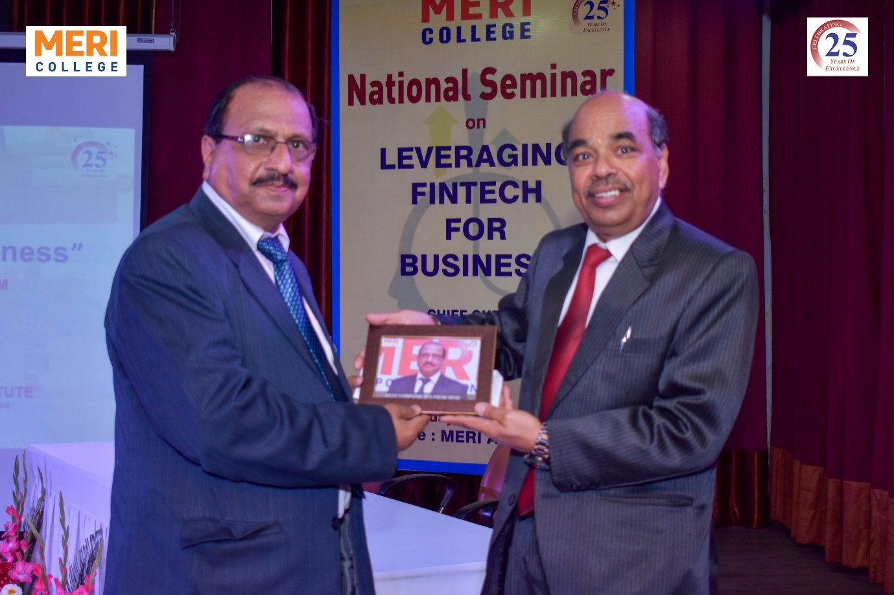
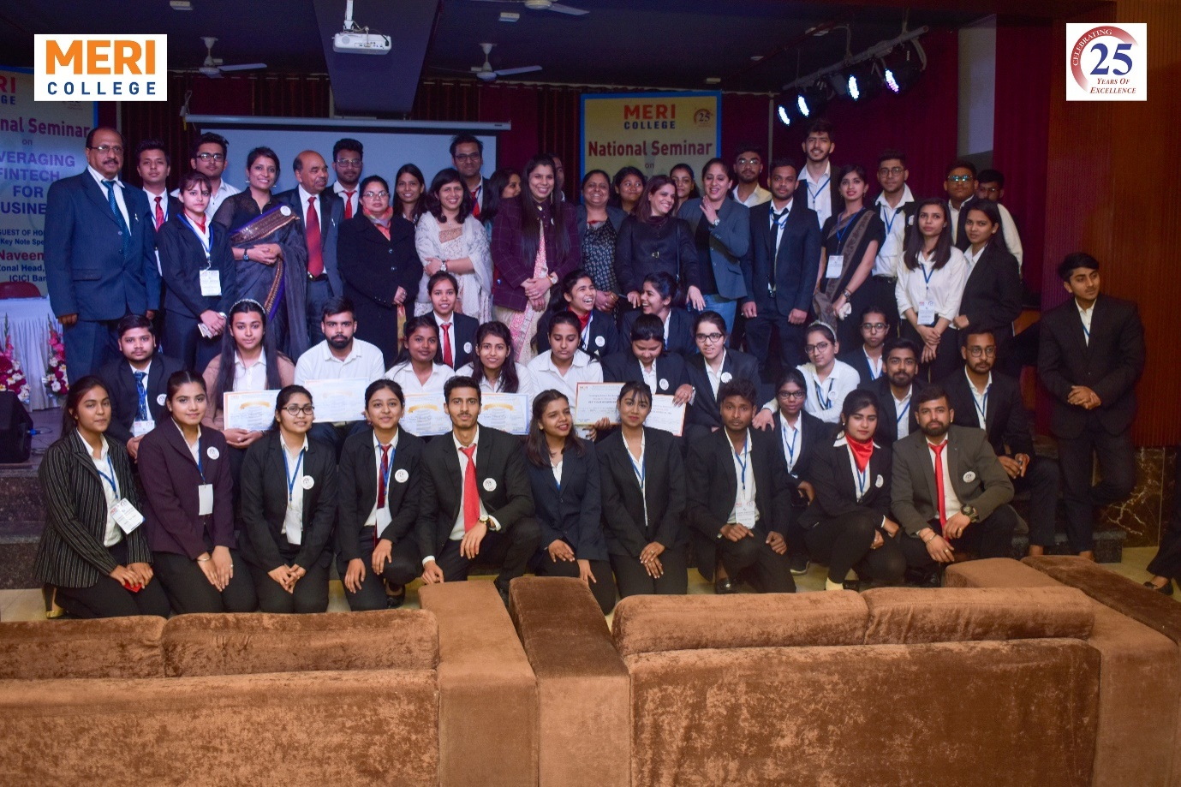
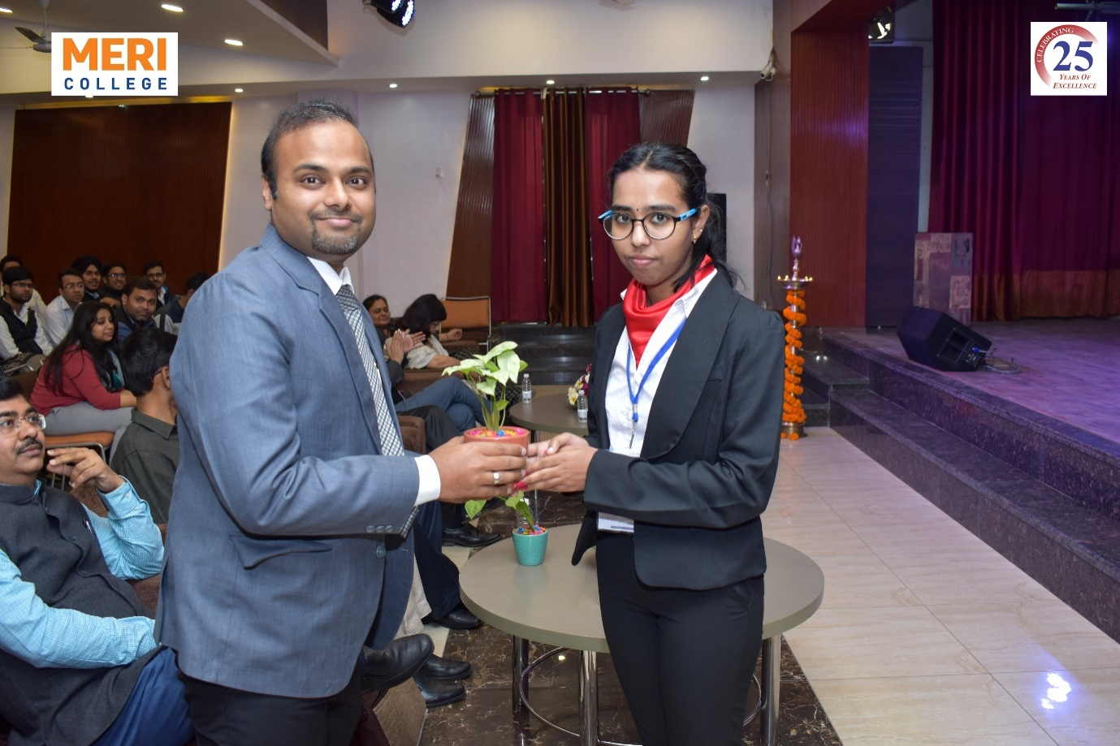
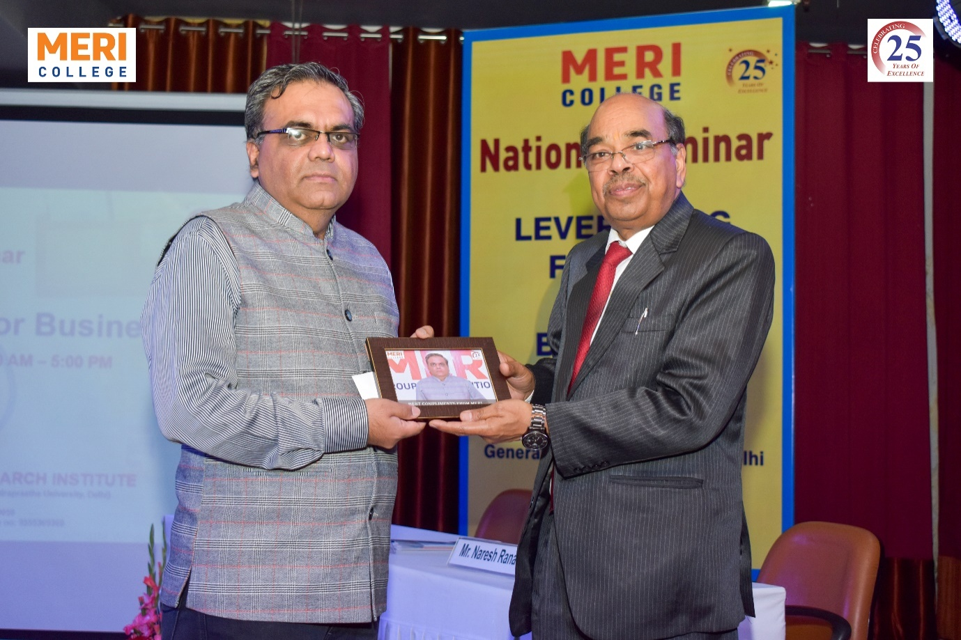

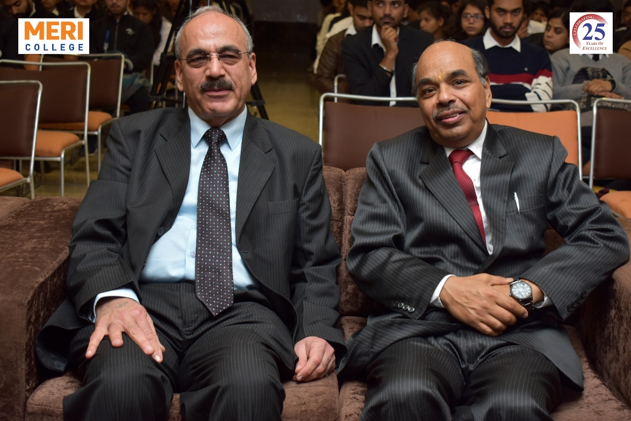
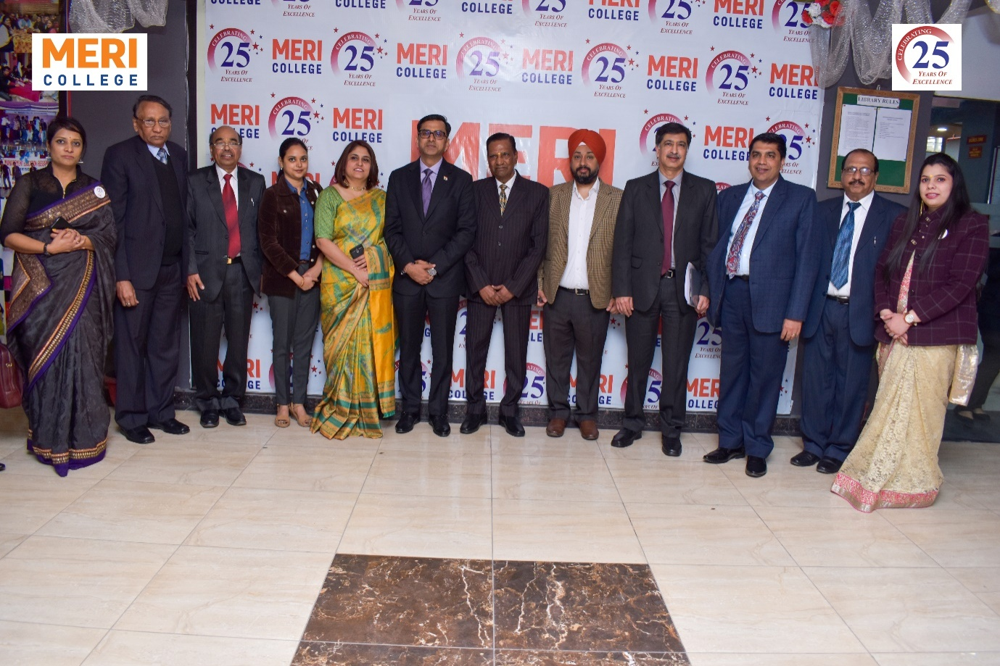
Management Education and Research Institute, Janakpuri, New Delhi organized National Finance Seminar 2020 on Leveraging Fintech for Business on February 22, 2020. The seminar, organised by the Internal Quality Assurance Cell of the collegeattempted to explore the emerging dimensions of ongoing technologies used in finance sector and to find out the innovative strategies to sustain in the turbulent business environment.
The programme commenced with its inaugural session graced by the Chief Guest, Sunil Soni, General Manager, Punjab National Bank; Guest of Honour, Naveen Gupta, Zonal Head, Delhi NCR, ICICI Bank; Shri I.P. Aggarwal, President, MERI Group of Institutions; Prof. Lalit Aggarwal, Vice President, MERI Group of Institutions; S.K. Aggarwal, Chief Finance Officer; Prof. A.K. Aggarwal, Dean; and other dignitaries. The session consisted of the traditional lamp lighting session by dignitaries, National Anthem, followed by MERI- Code of Conduct. The welcome address was presented by Prof. Lalit Aggarwal, wherein he spoke about the rapidly changing Fintech landscape and the impact of new innovations on traditional business models, along with the need to harness new technologies to build a better business. Furthermore, the inaugural address was presented by Shri I.P. Aggarwal, who deliberated about the recent emerging technologies around financial payments and markets, digital strategy, business model innovations and advanced analytics to be explored. This was followed with an address by the Chief Guest, Sunil Soni, who spoke great lengths about the current Fintech landscape from multiple stakeholders and shared his on-the-ground industry experience. The session continued with an address by the Guest of Honour, Naveen Gupta, who elaborated ways to be tech-savy, technologies empowering Fintech wave, recognizing cyber security issues and ways to mitigate them. The session concluded with a vote of thanks by Prof. A.K. Aggarwal deliberating on the evolution of Fintech and its tremendous change.
The programme progressed its first technical session with a presentation by the management students. This was followed byinformative deliberationsofthe speakers, G. L. Manchanda, former AGM, Punjab National Bank; and Akhil Bansal, Principal Consultant, PKC Advisory, respectively.
Furthermore, the session concluded with an interesting presentation by the management students, followed by the deliberations of the speakers, Mr.Sumeet Manocha, Associate VP, Hindustan Power Group; andMr.Mohan Mehndiratta, Director, ISACA, respectively.
The seminar, organised by Prof. A.K. Aggarwal, Dean, MERI College; Ms.Shikha Gupta, Assistant Professor, MERI College; and Dr. Kompal Barara, Assistant Professor, MERI College drew its curtain down with formal vote of thanks by Prof. A.K. Aggarwal, valediction and certificate distribution.

