APRENDEMOS 2020
18th National IT Seminar - “KNOWLEDGE ENGINEERING”

Jointly Organized By: Management Education & Research Institute (MERI) & MERI – College of Engineering & Technology
Date & Time: Saturday, 29th February, 2020 from 9:30a.m – 16:45p.m
Venu: Auditorium, MERI College, Janakpuri, New Delhi

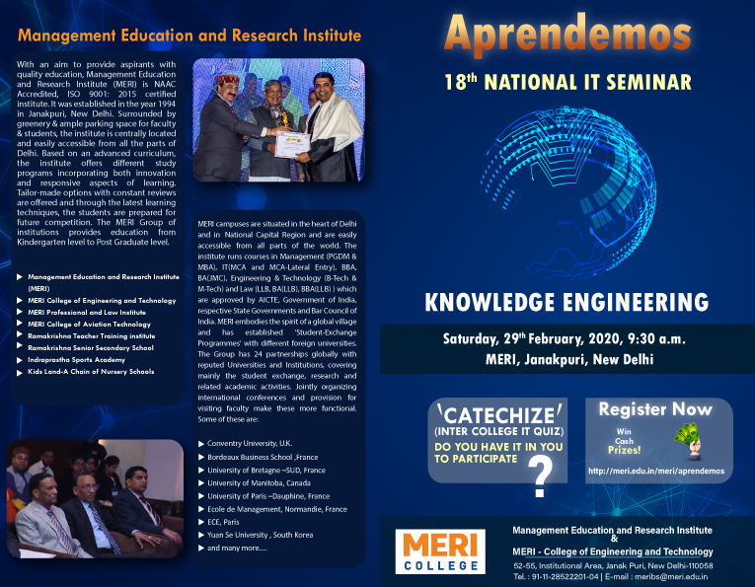
Coordinators : Prof. Ritu Aggrawal HOD (IT) ,Dr. Sumit Chauhan -Associate Prof. , Ms. Nidhi Pruthi, Assistant Prof.

Participants/Beneficiary: Consultants, Corporate Members, Faculty, Researchers , MCA & B.Teach. Students
Aprendemos, an annual corporate thought leadership series seminar which helps in enhancing the technical skills of students as it comprises of conceptual & practical knowledge.
This seminar was based on KNOWLEDGE ENGINEERING that tries to emulate the judgement and behavior of a human expert in the Data Science field that includes aspects of Machine Learning. This seminar organized for the knowledge of applications of Data Science and Machine Learning, Artificial Intelligence, classification and evaluation methods for Machine Learning Algorithms, Predictive Learning and Automated Knowledge base construction.
The objective of this Seminar was the immediate participation and contribution as a Data Science Team on big data and other analytics projects by
- Explain how analytics can be leveraged to create competitive advantage
- How the data scientist role and skills differ from those of a traditional business analyst
- Hands on Approach on:” Bayesian Machine Learning”
- Applying appropriate analytic techniques and tools to analyze big data, create statistical models, and identify insights that can lead to actionable results.
Management Education and Research Institute has taken up a step to provide a closer look at useful techniques in data science in a long-form interactive setting.
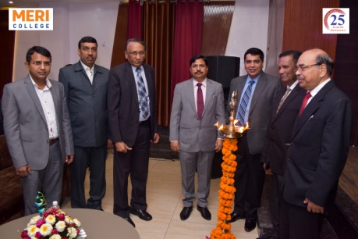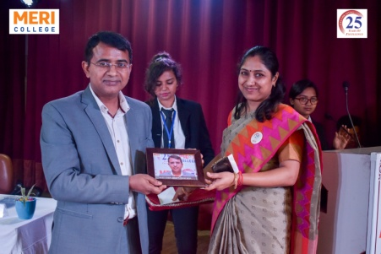
For this event the honorable chief guest was Dr. Ajay Kumar Gupta, Director, ICSSR .We welcome our chief guest Dr. Ajay Kumar Gupta for lighting the lamp along with other delegates.
The Skit on Knowledge Engineering was performed by MCA Students -Vineeta Rajput, Shubham Chandel, Mohak Lal, Ankeshwar Verma, Akash Vishnoi and Rajesh Jha. Students define it as – “Knowledge engineering skills are foundational to technological innovation and development that drive long-term economic growth and help solve societal challenges. Therefore, to ensure national competitiveness and quality of life it is important to understand and to continuously adapt and improve the educational and career pathways of engineers.”
Welcome speech was given by Sh. IP Aggarwal, President and the guiding force behind this whole endeavor of MERI. Prof. Lalit Aggarwal, vice president, MERI group of institutions gave his welcome address to the chief guest. After that Dr. Ajay Kumar Gupta told their experience and guides the students for further growth in knowledge engineering. At the end of inaugural session, Prof. A K Aggarwal gave a vote of thanks.
TECHINICAL SESSION I ON MAJOR APPROACHES TO ML: (12:15-13:15)
First Technical Session conducted by Mr.Vikas Kalra, Director, gotracko.com He gave an interesting session on Machine Learning focuses on the development of computer programs that can access data and use it learn for themselves.
TECHINICAL SESSION II ON REINFORCEMENT LEARNING: (13:15-14:15)
Second Technical Session conducted by Ms. Niharika Grover, Sr. Software Engineer, EXPEDIA. She told deeply about how RL can be used in robotics for industrial automation, used in machine learning and data processing, and also used to create training systems that provide custom instruction and materials according to the requirement of students.
TECHINICAL SESSION III ON BAYESIAN MACHINE LEARNING: (14:45-15:30)
Third Technical Session conducted byMr. Anshul Kumar Gupta, Data Scientist, WINGIFY He told about Bayesian machine learning which allows us to encode our prior beliefs about what those models should look like, independent of what the data tells us. This is especially useful when we don’t have a ton of data to confidently learn our model.
INTER COLLEGE IT QUIZ – ‘CATECHIZE’: (15:30-16:30)
Quiz session includes few rounds based on General IT, Programming language, logo and puzzle attended by students of MCA & BTECH which was of 1 hour and conducted by Jyoti Yadav, Dhanya Biju andChirag Malik.
In the inter-college IT Quiz competition, our esteemed judges were Prof. Ritu Aggarwal, HOD-MCA, MERI and Ms. Gurbrinder Kaur, Assistant Professor.

