REPORT
A VISIT TO THE CHINESE NEW YEAR CELEBRATIONS, 2020
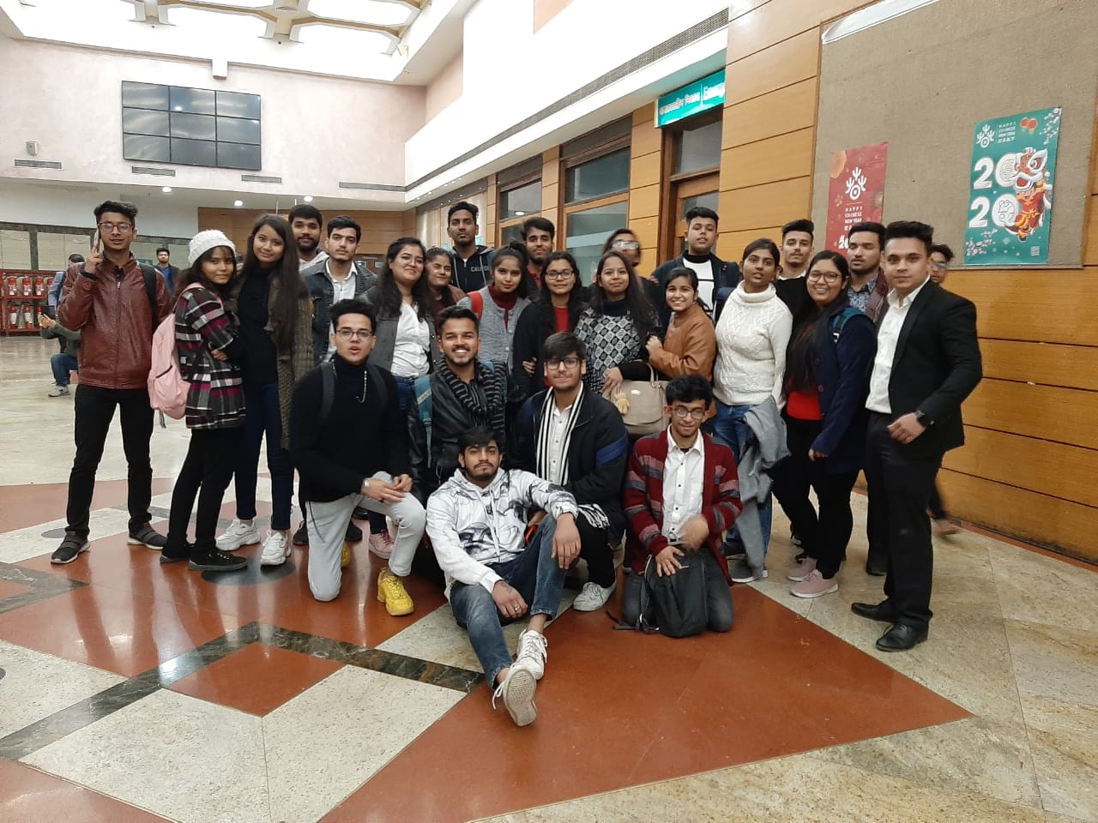
The students of Management Education and Research Institute (MERI) became a part of the Chinese new year celebrations, organized by the embassy of the People’s Republic of China held at Siri Fort auditorium, New Delhi on 14th January,2020.
Students of various coursesof MERI College came together to be a part of the grand elebrations and cultural extravaganza of Chinese art and culture. The Chinese Ambassador Sun Weidong hosted the colourful evening as many ambassadors and politicians were seen at the event. While Member of Parliament, Narendra Jadhav, was the chief guest, Pakistan’s Deputy High Commissioner, Syed Haider Shah, and Chinese counsellors were also there.
This Chinese New year also marked the 70th anniversary of Indo-Chinese diplomatic ties. The Chinese performances which depicted Chinese culture and history interested students the most. MERI has amiable relations with China, they have collaborated on various occasions and signed significant MoU’s. This celebration acted as a catalyst to further strengthen the India- China relationship through cultural exchange and dialogue and also gave the students a great exposure on how international relations worked. Students looked forward to be a part of more such grand celebrations organized for them in the near future.

