GUEST LECTURE BY DR. VIPIN GAUR
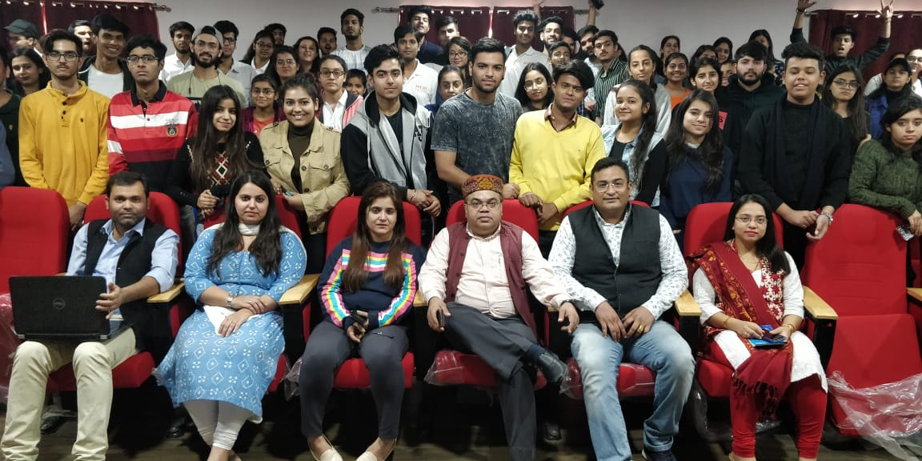
MERI college, Janakpuri: Students of BA(JMC) attended a guest lecture by DR. Vipin Gaur, general secretary, newspaper association of India on the topic of “the importance of medium and small scale newspapers.” The students gets to know about the number of news channels and newspaper publications. Students gets to know about hard work behind exclusive photages and how the reporters have to sit anywhere in the streets to get that one proof, struggle behind that live reporting, how the reporters have to work 24/7. Apart from this there was felicitation of the students who are chosen as “the student of the month”. They were given certificates and in the end there was a photo session also. Overall the students get to know about every hard work that the reporters do for their news even if it is a small news or a big news. Students learn about many things and experiences.

BY Sakshi Saklani

