Asia Media Systems between Government Control, Commercialization and Digital Youth.

MANAGEMENT EDUCATION AND RESEARCH INSTITUTE (MERI) organised a public lecture for the students of BA(JMC) on the topic ' Asia media system between government control, commercialization and digital and youth' . The institute was honoured to invite Mr. Puvaniten, Chairman National Unity of The Malaysian People Movement Party and Prof. Dr. Sara Chinnasamy, Associate Professor, University of the Technology Mara Malaysia.The session was been conceptualized to empower the media students in understanding various aspects of media functions and news industry, in order to bridge the gap between theoretical knowledge and practical exposure in the field of journalism.
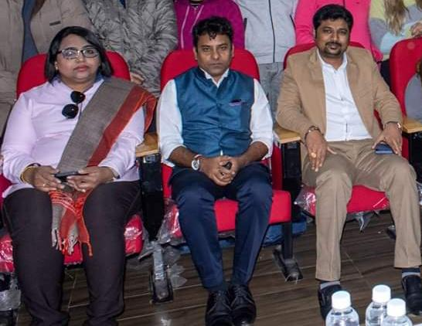
At first Prof .Sara gave all the details about how democracy differs in India and Malaysia. She gave the light on the topic ' freedom of expression' which is not allowed in their country but still they can express themselves through social media.
She gave all the data about how many countries uses the internet, what population in a country does so. According to her social media is a huge market and people can't think of their life without the internet, which is like a daily necessity for all people and it connects people from worldwide , you can know about what happening in the other side with social media . She also talked about inequality in her nation and the only right they have as a democratic nation is right to vote. She further added about how the Malaysia's oldest prime minister and youngest assembly member came as a talkative topic in news world.
Then, question answer round happened and some of the students of journalism department asked the questions and Prof. Sara answered them very beautifully.
After Prof. Sara session Mr. Puveniten was invited and he talked about the topic of fake news and how politicians plays their role to connect and solve the problem of citizens .He also advised the students to associate with any association so that they can get exposure and connect to people.
The guest lecture was worth attending and knowledgeable to connect with those mindful people was a great opportunity for the students of BA(JMC) department .All student left the hall with the thoughts of pure journalism.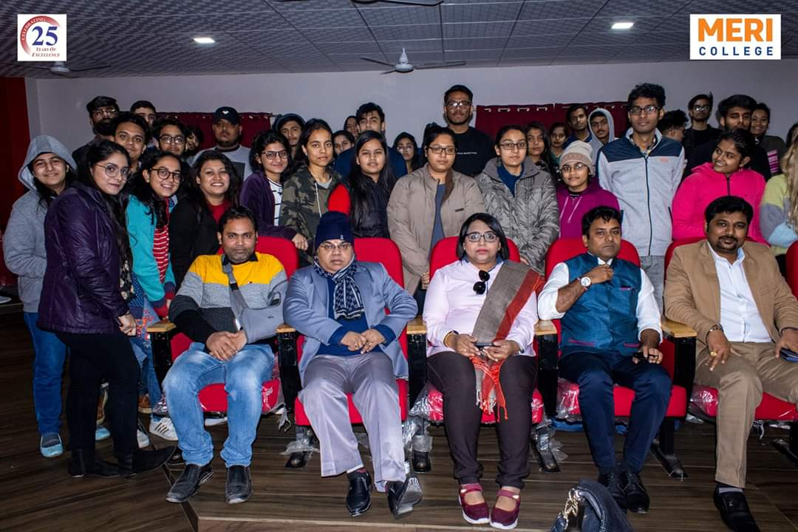Left to right: Asst. Professor Aamrendra Arya, Dr.Dilip Kumar(HOD) of Ba(jmc),Prof. Sara and Mr.Puvaniten

