GUEST LECTURE BY MR. SHANKAR KR. JHA ON JUDICIAL ACTIVISM

By: Tanishaa Mahindroo & Aksa Johnson

New Delhi, March 27, 2021: Management Education and Research Institute (MERI), affiliated to G.G.S. Indraprastha University, Delhi has organized a guest lecture on ‘Judicial Activism’ by Advocate Shankar Kr. Jha for the students and open to students of other colleges too. The event was attended by more than 100 students including students from Delhi University, Sri Venketeshwar College and students of Political Science Hons. along with the students of Journalism and Mass Communication.
The event was started by a welcoming speech by the anchors Mahek Anand and Swarnali Chaudhary. Followed by Saraswati Vandana for seeking the blessings of almighty. The Guest speaker was a renowned Advocate and a legal consultant with the rich experience of more than 25 years. The event was started by the opening speech of Dr. (Prof.) Dilip Kumar, Head of the Department. His speech was the perfect blend of the information and small stories based on legal ethics and aptitude which was indeed has made the environment lighter for the students.
Advocate Shankar KR Jhas’ lecture includes the preamble and its importance, briefing on judicial activism topic with special reference to various case studies. The lecture was indeed helpful for the students and questions raised by certain students were also being addressed by the Guest Speaker.
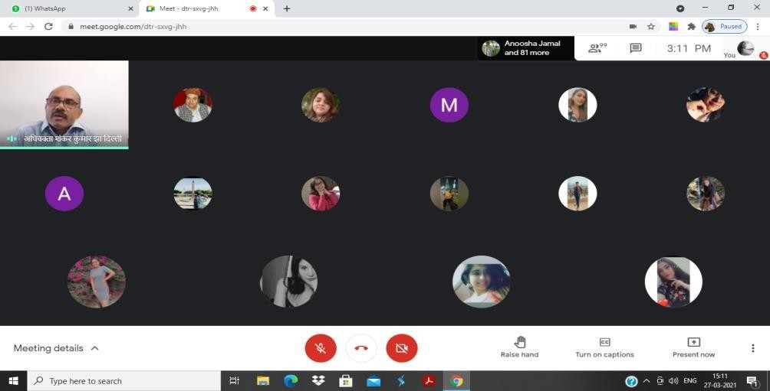
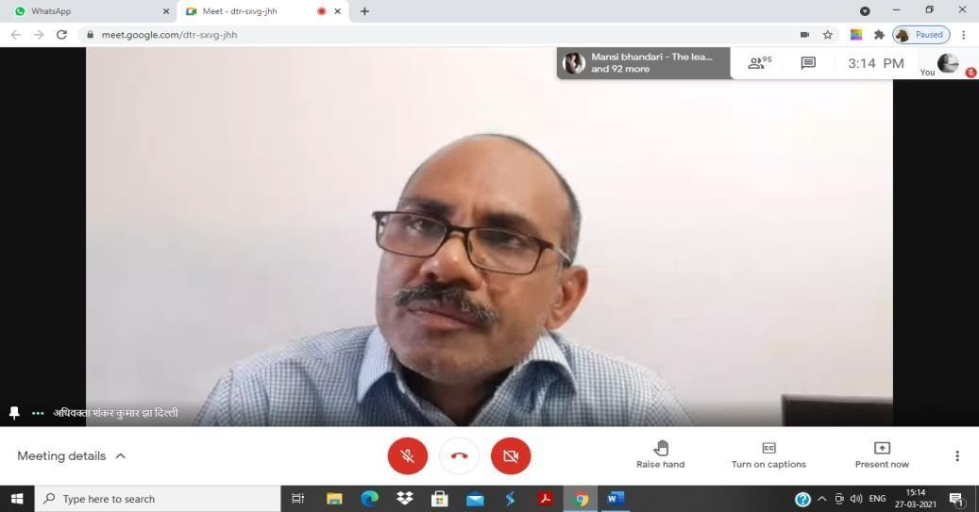
In the last, Dr. Yamini Khullar, Assistant Professor, Department of Journalism and Mass Communication presented the vote of thanks. At the end we would like to conclude, it was an insightful session where students were exposed to.

